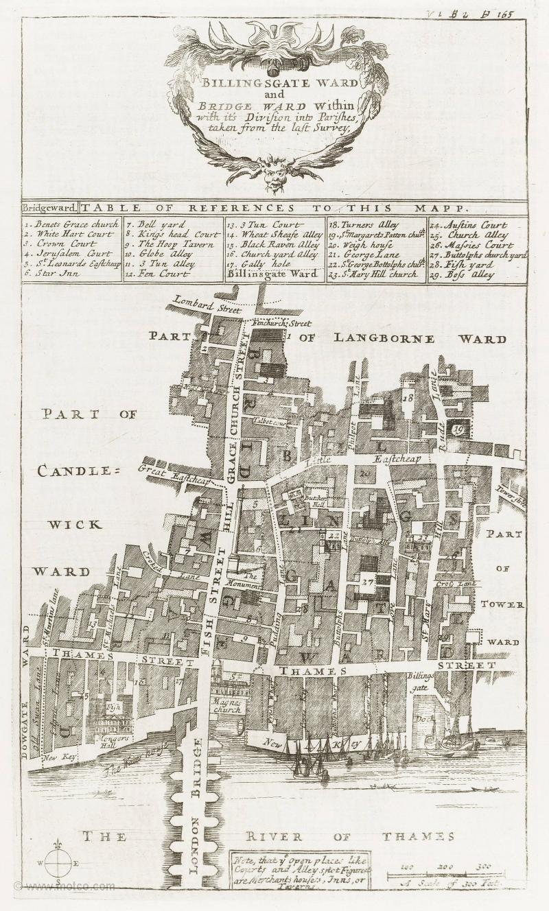
1. Please take us to “St Magnes Church” (aka St Magnus the Martyr), and find out a little about its history…

2. Please take us to “The Monument”, and find out a little about its history…

3. Please guide us to “St Dunstan’s Church”, and find out a little about its history…
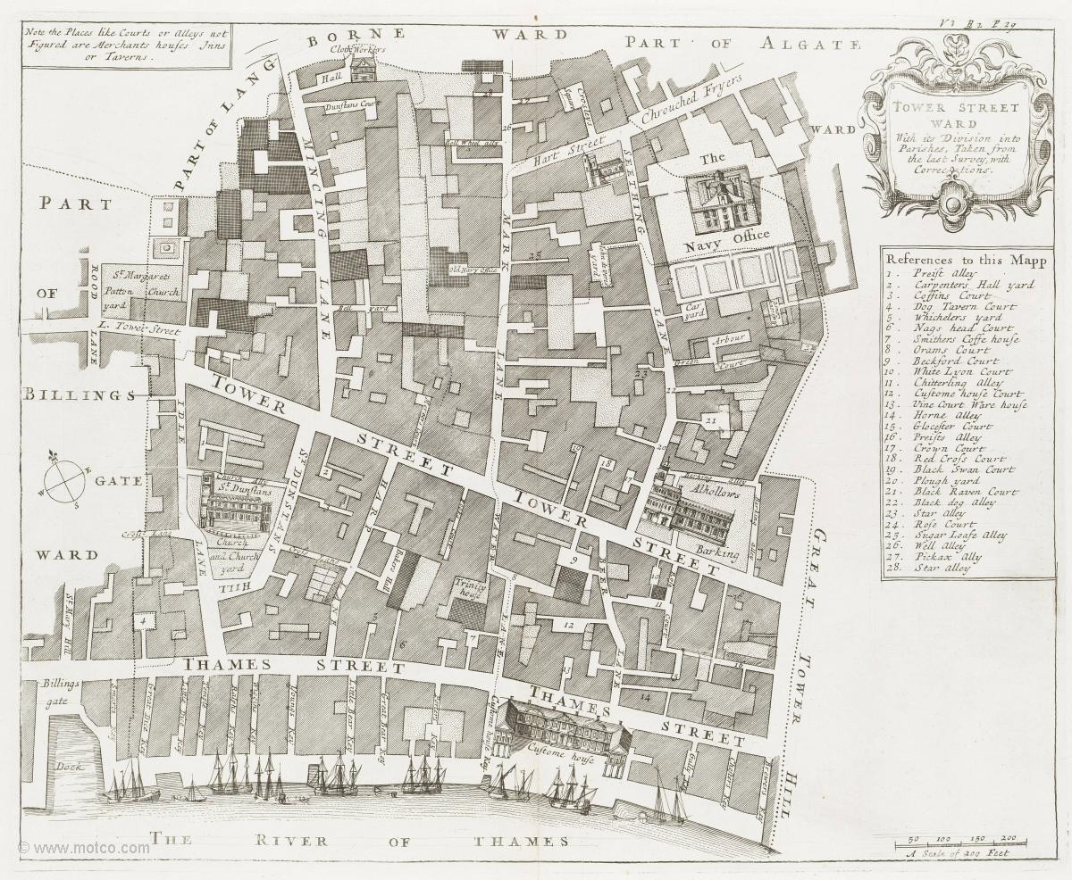
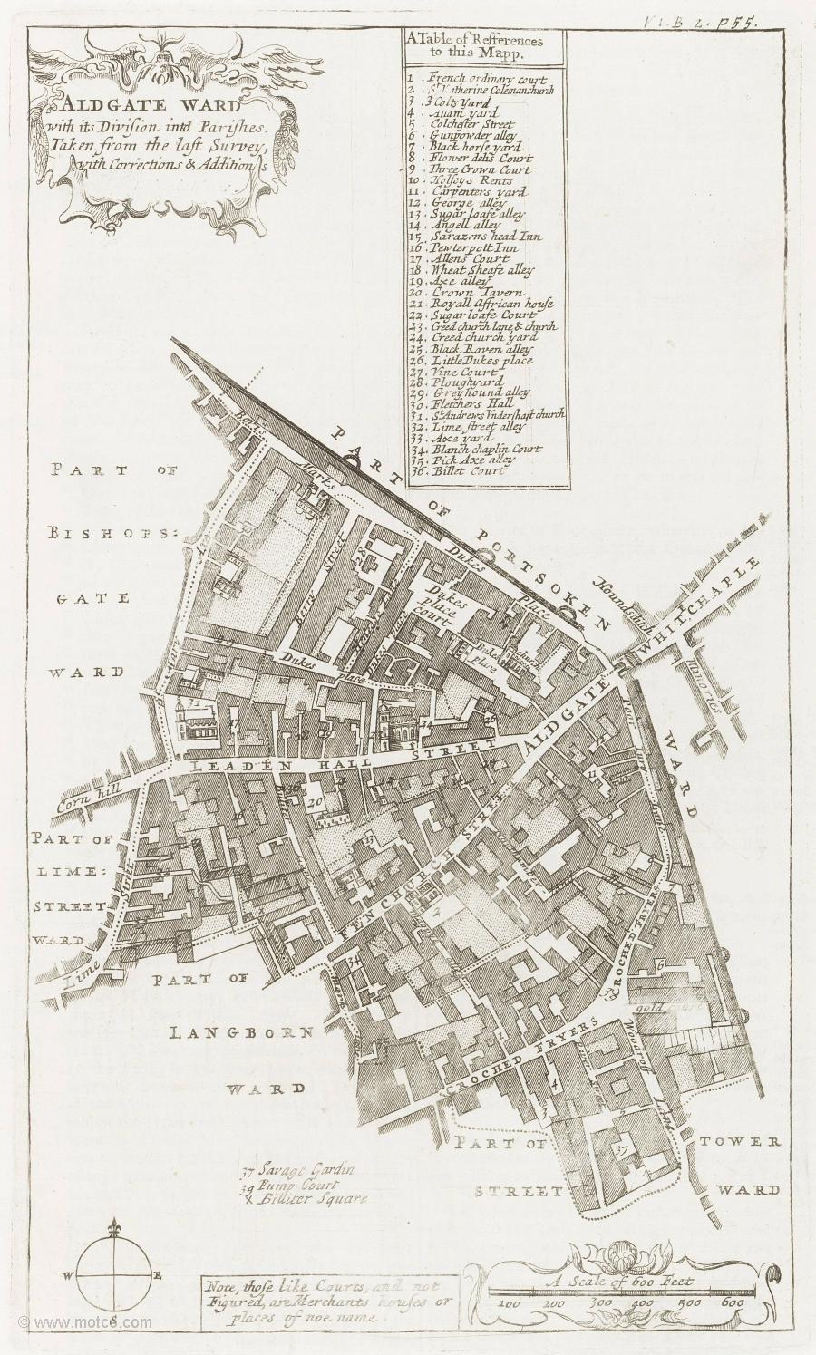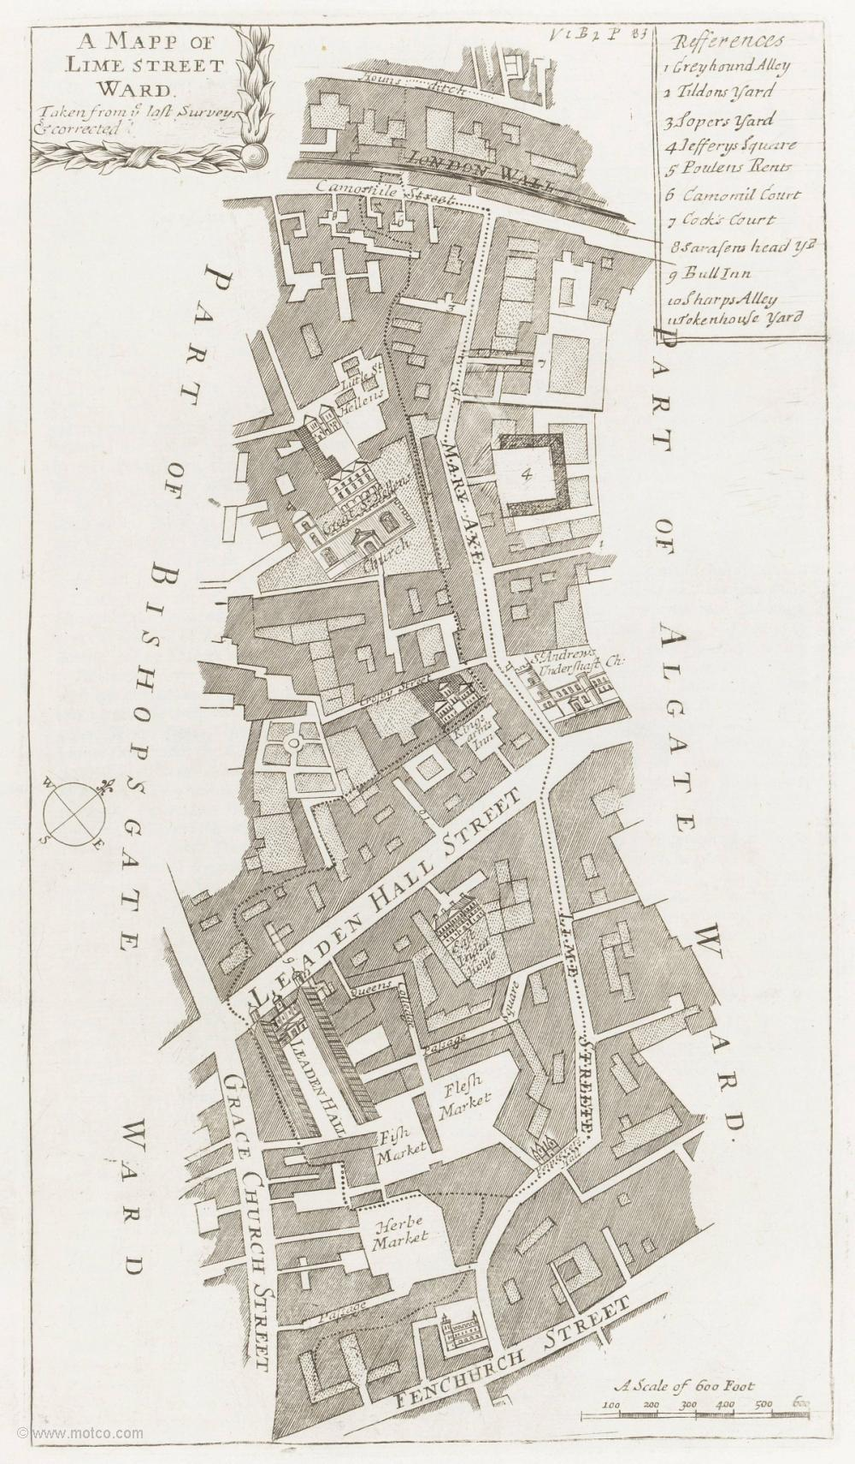
4. Please guide us to Leadenhall Market (“Leadenhall” on map 2), and find out a little about its history…

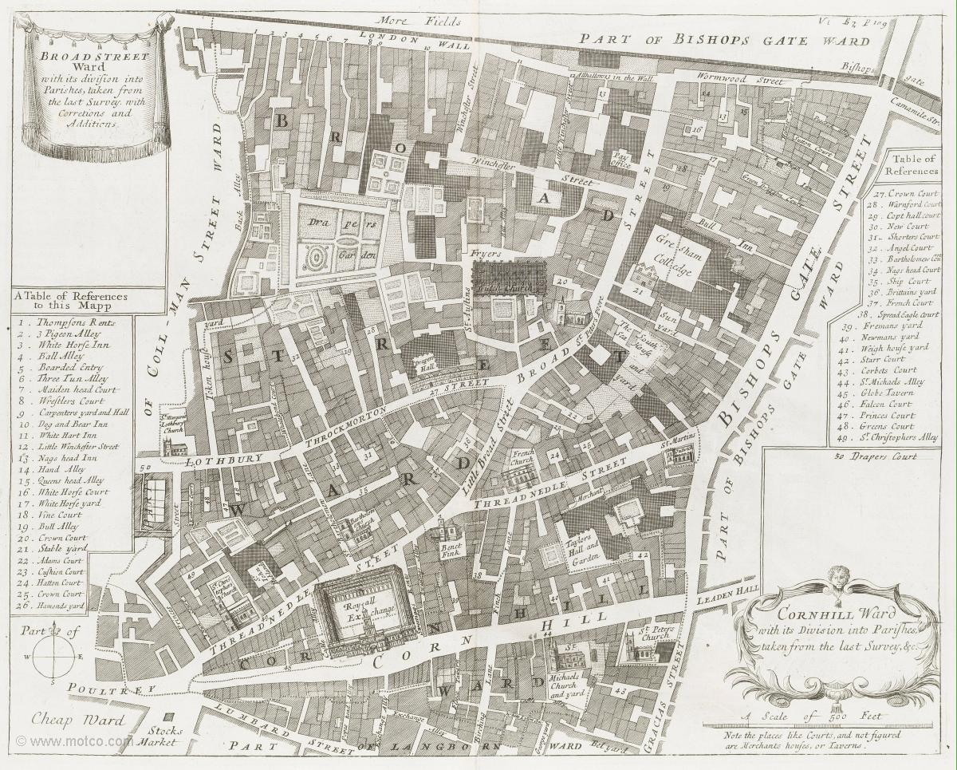
5. Please take us to the Royal Exchange, and find out a little about its history…

