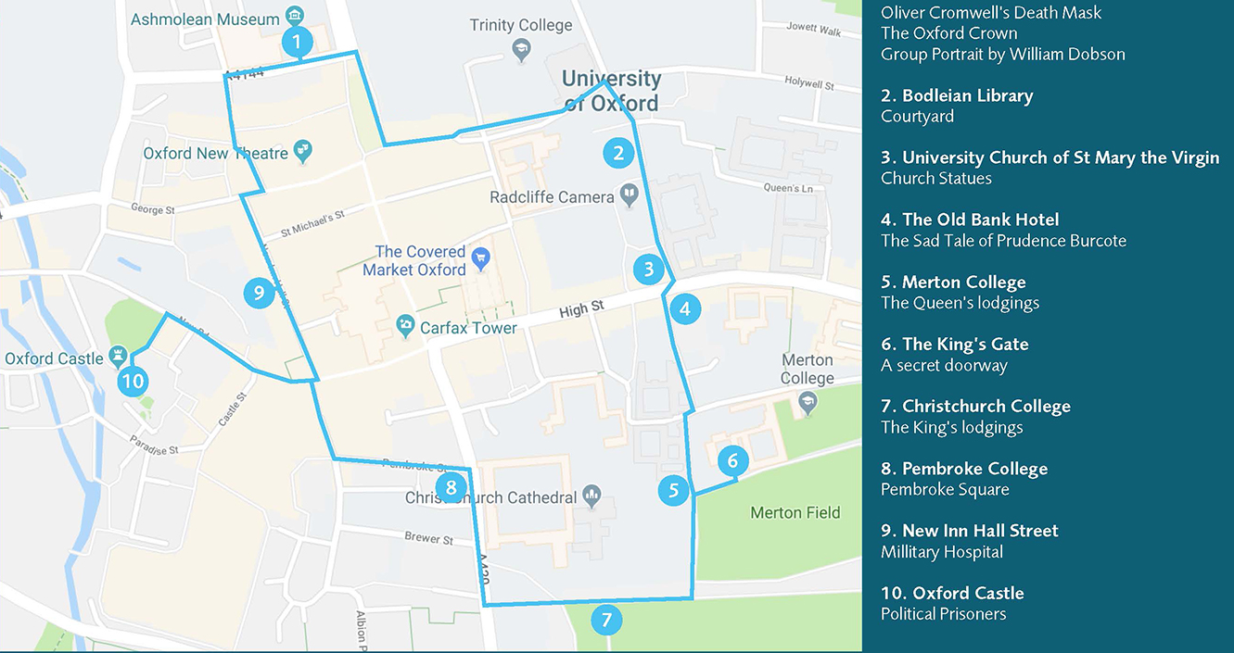

Why Oxford? Huge support of the population for Parliament, particularly London. Oxford strategically useful as a day's march from London, and its central point also good for reaching Gloucester and Bristol. Charles planned to build up his forces over winter then descend on London. Most of the colleges supported the king, but most of the town population did not. Oxford became capital for a time and the court was based here. New coins were issued in 1643. The colleges are instructed to pass over all their gold and silver tableware to be melted down for the war effort.
Cut through the covered market or via Turl Lane. Start at Bridge of Sighs, built 1914 linking Hertford College.
Bodleian Library: outside is the Earl of Pembroke, a 17th c gentleman with armour decorated with faces. The library itself has the oldest reading room still in use, Duke Humfrey's Library, which once housed the whole collection. Charles I requested borrowing a history book in December 1645 but the librarian refused. The hall of the Bodleian, Convocation House, was used as a venue for his remaining loyalist Parliament. In the end, Charles dismissed it as the 'mongrel' parliament and had two MPs arrested for encouraging negotiations.
Walk past the Radcliffe Camera, once housing the Radcliffe Science Library, 1749, now Bodleian Reading Room.
University Church of St Mary the Virgin: bullet holes in the statues from Parliamentary soldiers after storming Oxford. The heads were shot off Mary and the infant Christ but were restored in 1662.
Cross High Street, go down narrow Magpie Lane directly ahead.
Merton College: the warden of Merton supported Parliament and left Oxford, leaving it empty. It was occupied by Henrietta Maria and her entourage and ladies in waiting. She was attended by poets, painters, her pet dwarf Jeffrey Hudson and pet spaniels. The College formed part of the city’s inner defences and when it was under attack, she would’ve felt afraid.
Walk down Grove Lane towards Christ Church meadow. There’s a bricked up doorway in the wall which once served as the King’s gate, for Charles to visit Henrietta Maria.
Christ Church: the king’s residence over the Civil War. Charles took the best rooms, entertained guests in the great hall and also had meetings of parliament here. Alumni include Einstein, Locke, Lewis Carroll. Harry Potter filming.
The court was known for being flamboyant, with cavaliers dressing in lace, ribbons and gold trimmings. The townspeople resented this flaunting of wealth, the vast taxes they paid, and being forced to keep soldiers in their houses. Charles' large household included barbers, bakers, doctors and many domestic servants. Families loyal to the king also came. In the end Charles has to ban extravagant trimmings in order to make the cavaliers less unpopular. Before the war, Oxford's population was 10,000. Charles brought an extra 3000. The city became a vast military camp and couldn't cope, with rubbish and rotting waste polluting the rivers, leading to outbreaks and other diseases. In March 1643 the Council noted that 'great complaint is made to his Majesty for the ot cleansing the streets of this city, but suffering the filth and dirt to lie in the same not only to the scandal of the government of this place but also to the great danger of the breeding an infection amongst us.' Similar outbreaks of disease also affected parliament, e.g. the Earl of Essex' army were hit by typhus in 1643 causing a withdrawal from the Thames.
Walk up past Pembroke College, where Charles ordered all plates for the war effort. Up over the High Street, past Carfax Tower. Up Cornmarket Street back via the shops.
Ashmolean
Elias Ashmole serves in the Oxford garrison from 1644. Ashmolean founded in 1683. Artefacts include Cromwell’s death mask, an Oxford crown coin, etc.

Blenheim Palace
Blenheim Palace was built in the early 18th-century, as a gift from Queen Anne and Parliament to the 1st Duke of Marlborough, John Churchill, the military commander who led troops to a huge victory over the French in the Battle of Blenheim (13 August 1704), in the War of the Spanish Succession. The Duke was gifted the ruined Royal Manor of Woodstock, and £240,000 to build a grand new house in honour of his achievements.
Designed by Sir John Vanbrugh in the English Baroque style, Blenheim Palace was built between 1705 and 1722, with the Chapel (the last part of the Palace to be built) consecrated l 11 years after the death of the 1st Duke, in 1733. During its construction, the Palace became the subject of political infighting over the huge costs, as well as arguments between the Duchess and Vanbrugh over the style and design of the building. Interesting, it’s the only non-royal, non-episcopal country house in the country to hold the title of palace. And was designated a UNESCO World Heritage Site in 1987.
Over its near-300 years of history, Blenheim Palace has been a family home, mausoleum and national monument, but it’s arguably most famous as the birthplace and home of Sir Winston Churchill, England’s Prime Minister between 1940-45 and 1951-55. Churchill even proposed to his wife, Clementine Hozier, in the grounds of the Palace, in the Temple of Diana summerhouse on 11 August 1908.
In the early 18th century Queen Anne’s gardener, Henry Wise, designed the grounds of the palace in the formal style of André Le Nôtre’s famed gardens for Vaux-le-Vicomte and Versailles in France. Little remains of Wise’s landscaping, however, because tastes changed in the mid-18th century, and Lancelot (Capability) Brown was asked to redesign the grounds in his pastoral style of informal or seemingly natural landscapes of woods, lawns, and waterways. From his appointment in 1764, he worked to enhance the landscape with newly planted trees and man-man undulations. But it’s the Palace’s lake, which he created by damming the River Glyme, which is arguably the stand-out man-made feature.
During World War I, the Palace was used as a convalescence hospital for wounded soldiers. Then, during World War II, more than 400 pupils were evacuated there from Malvern College for one academic year.
Blenheim Palace opened its doors to the general public in 1950, and has attracted millions of visitors since then. Today, it’s the home of the 12th Duke and Duchess of Marlborough.

Battle of Blenheim
By the summer of 1704 the French King Louis XIV’s vast armies dominated mainland Europe. In his endeavours to create a French controlled super-state, the Sun King had defeated every alliance that had been thrown against him. Louis was now set to extend his frontier northwards to the Rhine, and to the south by installing a French prince on the throne of Spain.
The French also had plans to send an army to unite with Bavarian forces and then march down the Danube to capture Vienna. In an attempt to pre-empt this, the British under the command of John Churchill, Duke of Marlborough, and the Austrians under Prince Eugene of Savoy, decided upon a joint attack on Bavaria.
In one of the greatest military manoeuvres of history, Marlborough marched his army 200 miles from the Netherlands to Bavaria in near secrecy.
Courtesy of Blenheim PalaceThe Austro-British-Danish army had marched overnight in order to gain the element of surprise and arrived at the north bank of the river Danube. At a small village called Blenheim, near Höchstädt in Bavaria they faced the Franco-Bavarian lines under the command of the French leader, Marshall Tallard.
It was at Blenheim just after noon that the rival armies clashed on 13th August 1704. The French had fortified the village and their line extended almost 4 miles along a ridge. Prince Eugene attacked the Bavarians on the French left flank, whilst Marlborough attacked Blenheim directly, driving his cavalry and infantry straight through the centre of the French line and effectively splitting the enemy forces.
On the battlefield Marlborough’s calm and courage is said to have inspired those around him and for much of the day the armies remained locked in a close and deadly conflict for control of Blenheim village. Eugene reported: “I have not a squadron or a battalion which did not charge four times at least.”
It was not until darkness fell that Marlborough’s highly disciplined troops handed Louis XIV and France such a defeat as to rival that of Agincourt and Crécy.
The cost of the battle was staggering, with more than 9,000 men from Marlborough’s wing either killed or wounded and a further 5,000 from Eugene’s smaller wing. The loss to the French and Bavarian army was even worse with some 20,000 soldiers killed or wounded.
14,000 prisoners and 7,000 horses, along with scores of senior officers, 129 infantry colours, 110 cavalry standards and over 100 guns and mortars fell into British hands as did Marshall Tallard. Tallard was taken back to England and held prisoner where, disappointed by the food on offer in Nottingham, he introduced his gaolers to French bread and celery.
For the first time in two generations the French had suffered defeat and the results were immediate, with Bavaria conquered and Vienna saved. It would be Blenheim that would establish Britain as a world power, create the enduring reputation of the British redcoat and would shatter the Sun King’s vision of a French controlled Europe.
The news of this great victory was brought to England by Colonel Daniel Parke, who flogged his horse for eight days, to deliver a scribbled note on the back of a bar bill addressed to Marlborough’s wife, Sarah Churchill in London: “I have not time to say more but to beg you will give my duty to the Queen and let her know that her Army has had a glorious victory.”
In reward for his services in defending Holland and Austria from invasion by the French, a grateful Queen Anne granted to Marlborough the Royal Manor of Woodstock near Oxford, and signified that she would build him, at her own expense, a great house to be called Blenheim.
The building of the great house began in 1705, and an inscription on the East Gate reads: “Under the auspices of a munificent sovereign this house was built for John Duke of Marlborough, and his Duchess Sarah, by Sir J Vanbrugh between the years 1705 and 1722.
And this Royal manor of Woodstock, together with a grant of £240,000, towards the building of Blenheim was given by Her Majesty Queen Anne and confirmed by Act of Parliament…”
While the Duke remained busy giving his queen and country victory after victory overseas, his continued absence saw him fall from the queen’s favour. As a result, the money which had been promised for building Blenheim Palace failed to arrive, leaving the Duke owing £45,000 to masons, carvers, etc, including Vanbrugh the architect.
In the summer of 1712 all work on Blenheim Palace ceased. Following the death of Queen Anne in 1714, the Duke and Duchess of Marlborough negotiated with the unpaid builders and the Palace was eventually completed at their own expense.
It was at Blenheim Palace on the 30th November 1874 at 1.30am that Winston Churchill the ‘Greatest Briton of all time’ was born. Sir Winston Churchill’s love of Blenheim remained to his dying day. When he passed away in 1965, he chose to be buried beside his parents Lord and Lady Randolph Churchill, in the nearby churchyard at Bladon. And when Lady Clementine Churchill died in 1977, her remains were laid to rest beside those of her husband.

More detailed overview:
In the winter of 1704-5 John Churchill, duke of Marlborough engaged Sir John Vanbrugh to build a house in Woodstock Park, and together they chose a site overlooking the Glyme valley opposite the old royal palace. From the first, in accordance with the queen's wishes, the house was called Blenheim. The foundation stone was laid on 18 June 1705 on a site prepared by the royal gardener Henry Wise. Building continued at the Crown's expense until 1712, when, after the Marlboroughs had lost favour, the Treasury ceased to provide funds. On the queen's death in 1714 the Marlboroughs returned from voluntary exile, but little was done until debts to Blenheim workmen were partially settled in 1716. Building then continued at the Marlboroughs' expense, and the family took up residence in 1719. After the duke's death in 1722 Sarah, duchess of Marlborough, completed the chief features of Vanbrugh's house plan, together with outworks such as the Grand Bridge, the Triumphal Arch, and the Column of Victory. Her work was substantially complete by the early 1730s.
From the outset the building operation was on a vast scale, and by August 1705 Vanbrugh reckoned there were some 1,500 workmen on the site. The unexpected failure of the park quarries to provide suitable freestone increased the cost and complexity of the undertaking. At first local quarries such as Cornbury and Glympton were used, but soon more distant quarries were called upon, notably those at Burford and Taynton, whence 136 carters were hauling stone in the summer of 1706. In all over 20 quarries were used, the most distant being those at Portland, Plymouth, and Ross-on-Wye. Building materials and statuary were regularly carried by Thames barge from London. The building operation affected the economy of a wide area, providing abundant and well paid employment, but provoking sharp price rises: when Vanbrugh was granted large quantities of royal timber from Wychwood forest in 1709 it was hoped that local timber prices would fall to levels which country builders might afford. Individual fortunes were presumably made but distress and bankruptcy were precaused when the money supply failed. More enduring was the development of Blenheim as a focus of tourism, which began soon after the foundation stone was laid.
The queen's decision to pay for the house was never officially recorded, and warrants of June 1705 appointing the architect and joint comptrollers of works were issued by the Lord Treasurer at the duke's request, making no reference to the Crown's interest. It was understood that costs would be met from the Civil List, but those handling the payments (Samuel Travers, Surveyor General of Crown lands, and John Taylor, his deputy) were accountable not to the Treasury but to the duke. When the Marlboroughs' political power declined the unbridled expenditure on Blenheim was at once called into question.
According to Vanbrugh the duke at first had in mind a house costing £40,000, but in July 1705, when Sir Christopher Wren, Surveyor General of royal works, visited the site, he estimated the cost at c. £100,000. That estimate omitted many features of the eventual plan, notably the service courts, the ambitious northern approach, the heightening of the main block, and the laying out of the gardens and park. The model which Vanbrugh later claimed that the queen had approved and which he had 'exactly followed' evidently postdated Wren's estimate and several changes of plan, and may have been prepared as late as 1708. Vanbrugh's own estimates were unreliable: in July 1707 he was expecting to finish in 1709, but by 1708, after delays in acquiring suitable stone, he recognized that even two more seasons would leave the west side unfinished. In October 1710, when the problem of money supply became acute and the duchess ordered all work to cease until the Crown sanctioned further payments, Vanbrugh felt that he might 'almost' undertake to finish for another £30,000, but four years later was still estimating over £54,000. When pressed he admitted that the total cost of the building would be £ 287,000, 'a large sum for a house, but a poor reward for the services that occasioned building it.'
The Crown's expenditure before its commitment ceased on 1 June 1712 (excluding £ 13,000 spent on clearing Woodstock park of 'incumbrances') was £ 220,000, and it was later accepted that a further £ 45,000 was owing to Blenheim workmen. After work restarted in 1716 the Marlboroughs spent a further £ 32,000 up to 1720, and the duchess claimed to have spent another £ 25,000 after the duke's death, out of £ 50,000 left to her to finish Blenheim. Elsewhere she claimed that the house had or would cost the family £ 100,000 to complete. Expenditure in several years is unaccounted for, and the extent of unsettled debts uncertain, but it is unlikely that the building cost less than £ 325,000. Vanbrugh frequently protested his frugality, attributing rising costs largely to the failure of the park quarries. The duchess regarded him as a spendthrift who paid excessive wages, wasted materials, and without authority changed already extravagant plans.
The question whether Blenheim workmen were employed by the Crown or the Marlboroughs was central to the prolonged disputes over debts. As early as 1713 a minor creditor brought a successful action against the duke, but the chief creditors, the Strongs, masons, were persuaded to await settlement by the Crown. In 1716, after acknowledging debts much higher than the duchess thought reasonable, the Crown paid only a third to creditors, who then sought redress from the Marlboroughs. Several were successful, including the Strongs who were awarded over £ 12,000 in 1721. The duchess brought an action against 401 Blenheim workmen on various charges, and obtained an injunction forbidding Vanbrugh to pursue her family for debts incurred before 1712. Although Vanbrugh's debt was later acknowledged by the Crown others were less successful, and Henry Joynes, comptroller of works and the meticulous accountant of the Blenheim building operation, was still seeking settlement in 1748.
In the first phase of building Nicholas Hawksmoor was responsible for much of the detailed execution of the design. Wren was consulted over certain aspects of the plan, notably the northern approach to the palace. Henry Joynes and William Boulter were joint comptrollers of works from 1705, and Boulter was succeeded on his death in 1708 by Tilleman Bobart. In 1716 Vanbrugh resigned as architect, and by then Hawksmoor and Joynes had also left Blenheim. Thereafter the duchess took control of the building work with the help of James Moore, cabinet maker, John Desborough, clerk of works, and Tilleman Bobart, who continued at Blenheim (though increasingly confined to garden business) until 1719. From 1722 Hawksmoor was again engaged to design or complete major features such as the great gallery, the chapel, and the Triumphal Arch, but was overlooked when the final stages, notably the Marlborough tomb and the Column of Victory, were undertaken.
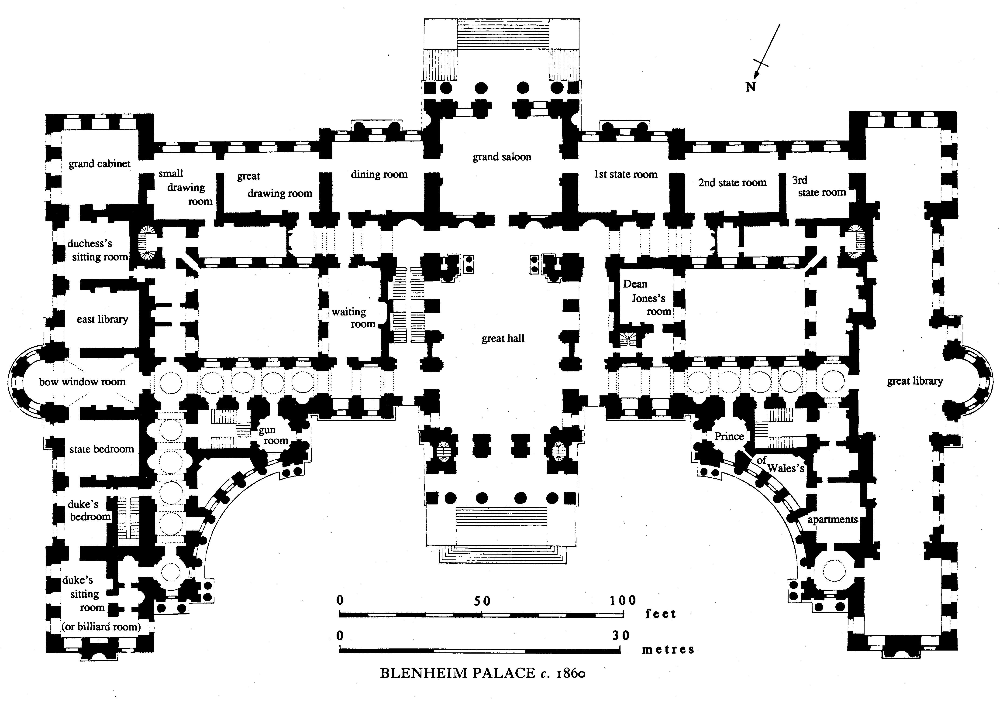
From the outset Blenheim housed a large domestic staff, under the control of a resident steward; in 1764 the Marlboroughs had c. 90 servants of whom over 70 were at Blenheim and their wages and liveries cost nearly £3,000 a year. In the early 19th century it was estimated that there were 187 furnished rooms in the palace and there was a staff, not all resident, of c. 80. The penurious 5th duke was forced to reduce his establishment greatly. In 1841, when the 6th duke was in residence, there were 30 servants and a governess in the palace, and in 1871 a similar number; in 1851 and 1881, when the family was absent, there were fewer than a dozen resident servants. A higher proportion of the staff lived out as park lodges proliferated and estate cottages were built in nearby villages. At the end of the 19th century the inside staff was between 35 and 40, and the outside staff between 40 and 50, excluding the hunting department based at Home Farm, Bladon. In modern times, although the family ceased to reside during the tourist season, the staff was enlarged as the palace became a commercial enterprise; by the 1980s there were c. 90 permanent employees and twice that number in the summer months.
Treasures: Silver centrepiece, Saloon: made in 1846 for the 6th Duke by Garrad’s of London. It is sterling silver and weighs around 110lbs. It depicts the 1st Duke in the aftermath of the Battle of Blenheim still sitting astride his horse and writing a note home to his wife, Sarah, to inform her of his victory (the Blenheim Dispatch). There is a story that during their unhappy marriage Consuelo liked to have the centrepiece on the table at meal times so she did not have to look at, or talk to, the 9th Duke while they ate.
Boulle Coffer, 3rd state room: Designed by André Charles Boulle in around 1685, the Louis XIV coffer is among the finest examples of a process known as marquetry which was pioneered by the French master cabinetmaker.
There is also a Boulle Marquetry Writing Table in the 1st state room, 1700.
Children’s chair, red drawing room: A beechwood fauteuil d’enfant, Louis XVI, c. 1780. The oval paddle back within a guilloche and husk carved frame, the padded down-curved arms and drop-in seat over a guilloche seat rail and on leaf carved volute legs, bear old label.
Rabby Clock: A red-stained tortoiseshell and gilt bronze religieuse table clock, Louis XIV, c. 1690. Signed Rabby A Paris. The oldest clock in our collection located in the Green Drawing Room.
Adoration of Magi Painting, China Ante room. Carlo Dolci, c.1640. The only painting with religious iconography remaining in our collection after the big sale in 1886. Dolci was one of the most famous artists in Florence in the 17th Century. The quality of the details is extraordinary, highlighting the exotic garments worn by the Kings and the main role of the light contrasts making the figures and fabric have a beautiful relief and movement.
Lord Ivor coronation robes, Long Library. Worn by Lord Ivor at the coronation of George V in 1911.

