Landmarks in London History
HT52217A / HT53217A
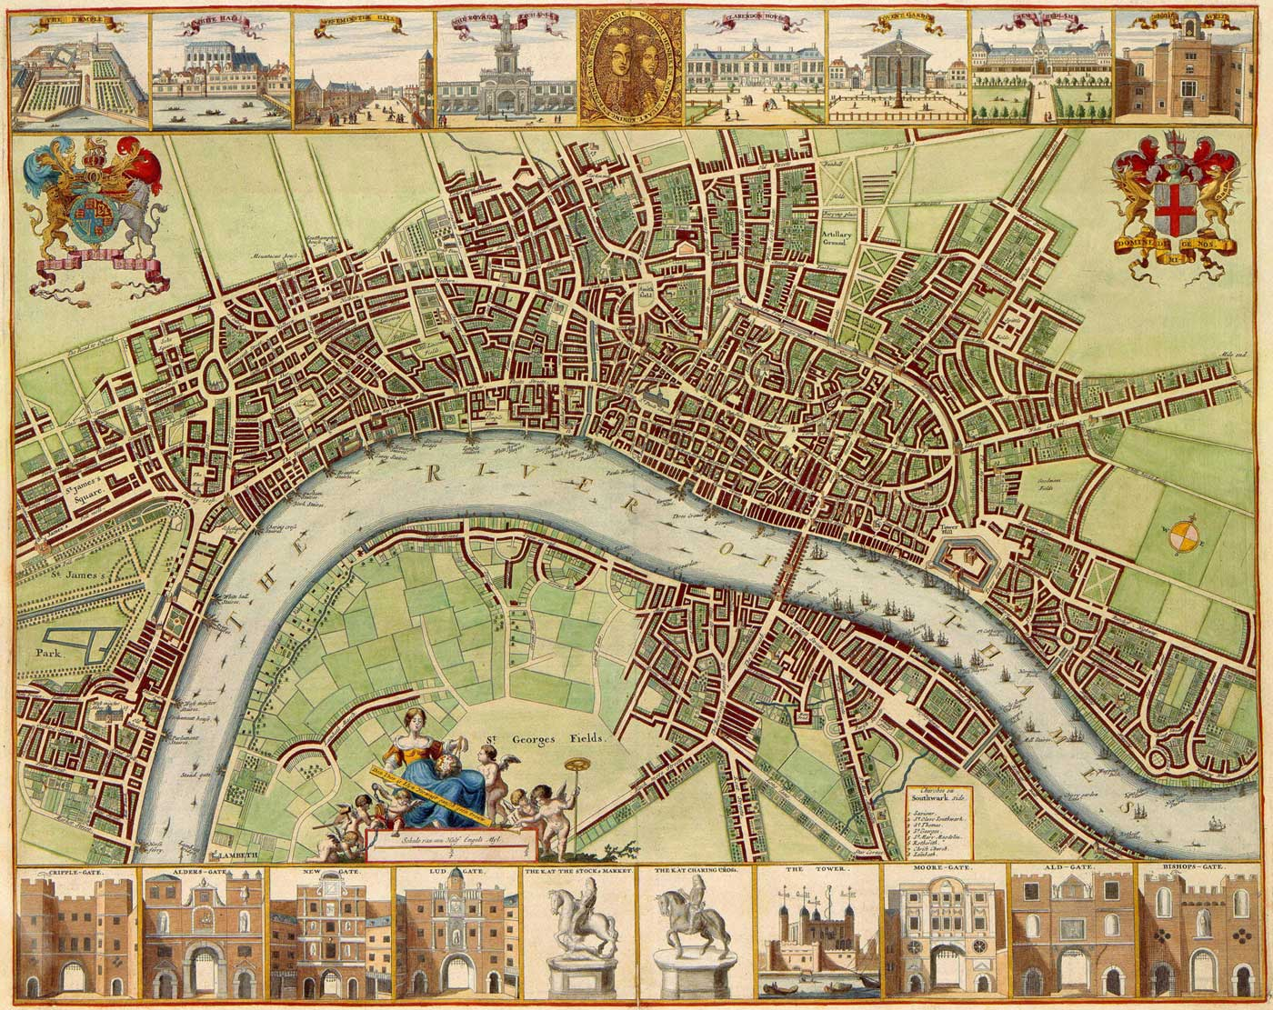
Wenceslaus Hollar, Map of London (1675)

Course convenor and tutor: Dan Taylor (d.taylor@gold.ac.uk)
Welcome! Here is a course summary, guidance for initial reading, general bibliography and indicative readings for each week.
Classes are on Fridays, beginning on Friday 6th October.
Lecture: 10-11 in RHB 142
Seminar 1: 11-12 in HH15
Seminar 2: 12-1 in MM224
Note that seminars involving walking tours will take place slightly later.

Course summary
This module will provide an introduction to the social and cultural history of London. Through the study of primary and secondary source material, along with field trips to sites of cultural and historical significance, students will gain an understanding of the development of the city’s history and historiography.
Surveying London from the early modern period until the 1970s, students will be able to assess key themes in development of London as a world city and compare them to current perceptions of the urban environment. A key aspect of the module is the idea of simultaneity; that past and present London and Londoners develop, grow and are built on top and alongside each other.
The module takes a primarily thematic approach to London history, looking at ‘landmarks’ in terms of periods, events, people, ideas, locations and buildings. The module will also engage students with methodological approaches to urban and metropolitan history and ask questions about how the history of a city like London can and should be approached and studied.

Guidance for initial reading
Each week we will read and discuss selected primary and secondary material covering thematic areas of London’s history. Key texts are assigned for each week that you will need to read ahead of class. A selected bibliography is provided below, but it is not exhaustive, and you will be expected to carry out further research for your assessed work.
Most of our primary course texts are available in Goldsmiths’ library, and some are also available online. But you will need to venture beyond Goldsmiths in order to consult some of the books on the list. Senate House Library should be your first point of call – it has a wider selection, and also access to a wider range of journals than through Goldsmiths’ system. You can also use Search25.ac.uk to search other university library catalogues in the London/South East area, which you can then access through the SCONUL scheme or through Inter-Library Loans.
These online resources may also be useful:
Bibliography of British and Irish History: fully searchable bibliography of a huge number of British historical works, including books, journal articles and book chapters.
British History Online: extensive digital library of primary and secondary sources, 1300-1800
Victorian London: vast dictionary of 19th century source material
20th Century London: historical database produced by an association of London museums, with a number of digitised sources.

Selected bibliography – London histories
Below are some well-regarded overviews of London’s history. I recommend consulting at least two from the list before the course begins for a good overview of contexts, and among these particularly one of the broader histories by Ackroyd, Porter or White. You are also encouraged to spend a day immersed in one of London’s museums before the course begins, for instance the Museum of London, or Museum of London Docklands.
Peter Ackroyd, London: The Biography (London: Chatto & Windus, 2000)
Peter Ackroyd, London Under (Oxford: ISIS Pub., 2011)
Peter Barber, London: A history in Maps (London: The British Library, 2012)
Robert O. Bucholz and Joseph P. Ward, London: A Social and Cultural History, 1550-1750 (Cambridge: Cambridge University Press, 2012)
David Feldman & Gareth Stedman Jones, eds., Metropolis London: Histories and Representations since 1800 (London: Routledge, 1989)
Celina Fox, Londoners (London: Thames & Hudson, 1987)
Simon Foxell, Mapping London: making sense of the city (London: Black Dog, 2007)
Pamela K. Gilbert, ed., Imagined Londons (New York: State University Press, 2002)
Christopher Hibbert, London: the Biography of a City (London: Penguin, 1980)
Lucy Inglis, Georgian London: Into the Streets (London: Penguin, 2013)
Stephen Inwood, A History of London (London: Papermac, 2000)
Stephen Inwood, City of Cities (London: Macmillan, 2005)
Joe Kerr, et. al. eds., London from Punk to Blair (London: Reaktion Books, 2ndedn., 2012)
Doreen Massey, World city (Cambridge: Polity, 2007)
Susan Okokon, Black Londoners, 1880-1990 (Stroud: The History Press, 1998)
Liza Picard, Restoration London: Everyday Life in the 1660s (London: Phoenix, 2003)
Liza Picard, Victorian London: The Life of a City 1840-1870 (London: Phoenix, 2006)
Roy Porter, London: A Social History (London: Penguin, 2000)
Alan Robinson, Imagining London, 1770-1900 (Basingstoke: Palgrave Macmillan, 2004)
Jonathan Schneer, London 1900: The Imperial Metropolis (New Haven: Yale University Press, 1999)
Richard Tames, London, a cultural history (Oxford: Signal 2006)
Gavin Weightman & Steven Humphries, The Making of Modern London (London: Ebury, 2007)
Jerry White, London in the Eighteenth Century: A Great and Monstrous Thing (London: Bodley Head, 2012)
Jerry White, London in the Nineteenth Century: A Human Awful Wonder of God (London, Vintage 2008)
Jerry White, London in the Twentieth Century: A City and its People (London: Vintage, 2008)
Jerry White, London: The Story of A Great City (London: Andre Deutsche, 2010)

Walking London
Wandering around the city is a vital part of this course, and we will be going on a number of walks around London together. You also be writing about landmarks found on your own walks as part of your blogging assessment. Therefore you are warmly encouraged to begin undertaking your own walks around the capital, getting lost as much as possible. There are a number of excellent books about walking London, as well as the broader history of wandering, for instance in the traditions of the flaneur or psychogeography. I recommend familiarity with one before the course starts.
Matthew Beaumont, Nightwalking: A Nocturnal History of London (London and New York: Verso, 2015)
Merlin Coverley, Psychogeography (Harpenden: Pocket Essentials, 2010)
Stephen Glinert, The London Compendium: A Street-by-street Exploration of the Hidden Metropolis (London: Penguin, 2002)
Stephen Millar, London’s Hidden Walks [Three Volumes]. (London: Metro, 2011)
Geoff Nicholson, The Lost Art of Walking: The History, Philosophy and Literature of Pedestrianism (New York: Riverhead Books, 2008)
Laura Oldfield Ford, Savage Messiah (London: Verso, 2011)
Tina Richardson, Walking Inside Out: Contemporary British Psychogeography (London: Rowman and Littlefield, 2015)
David Rosenberg, Radical Footprints: A Guide to Uncovering London’s Radical History (London: Pluto Press, 2015)
Iain Sinclair, Lights Out for the Territory (London: Granta, 1997)
Rebecca Solnit, Wanderlust: A History of Walking (London: Verso, 2001)

Week 1. Surveying London
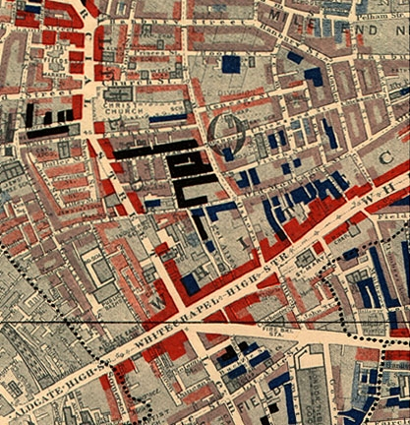
Whitechapel, from Booth's survey of London, 1889
This week we introduce the subject of this course, London, and the way it has been imagined, dramatised, recorded and surveyed. From early attempts to map the city to the vast urban biography of Ackroyd, we will explore how the city and its landmarks have been documented, from the physical survey of John Stowe (1603) to the diaries of Pepys (1660-9) and the observations of London characters in John Gay’s Trivia (1716).
Indicative reading:
Peter Ackroyd, London: The Biography, “The City as Body” [Preface], Chapters 1 and Chapter 8.
Matthew Beaumont, Nightwalking: A Nocturnal History of London, Chapter 2.
Clare Brant & Susan E. Whyman, eds., Walking the Streets of Eighteenth-Century London: John Gay’s Trivia (1716), (Oxford: OUP, 2007), introduction, pp. 1-24
Samuel Pepys, Diary (1660-69) – accessible online here. Please pick one month’s entry and read a few entries.
Michael J. Power, ‘John Stow and his London’, Journal of Historical Geography, 11 (1985) pp. 1-20
John Stowe, A Survey of London (1603) – accessible online here: please read one entry, for instance “Bridgewarde Within”, “Sports and pastimes of old time”, “The singularities of London”.

2. Life and Death
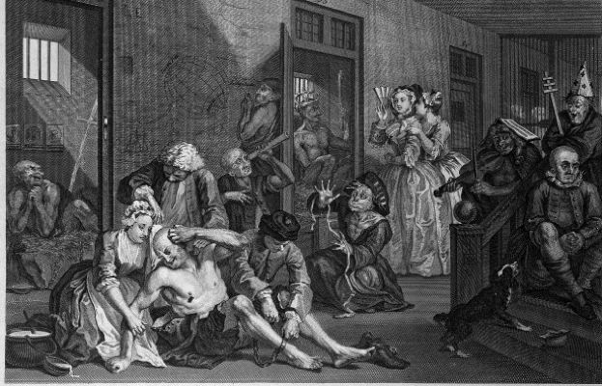
Hogarth, Bethlem Hospital, from A Rake's Progress (1734)
This week we turn to life, sickness and death in early modern London. What can we learn from bills of mortality about how Londoners lived and died? How did London deal with its dead? We will explore how hospitals, burial grounds, ‘Bedlam’ and philanthropic welfare developed and emerged over this period. For the seminar we will take a walking tour of Bunhill Fields Cemetery and St Barts Hospital.
Indicative reading:
John Graunt, Natural and political observations mentioned in a following index and made upon the Bills of Mortality, (1676) http://www.ac.wwu.edu/~stephan/Graunt/.
Paul Slack, ‘Hospitals, workhouses and the relief of the poor in early modern London’, in Ole Peter Grell and Andrew Cunningham (ed.), Health care and poor relief in Protestant Europe, 1500-1700 (London and New York: Routledge, 1997), pp. 229-246.
Patricia Aldridge, ‘Bedlam: Fact or Fantasy?’ in William F. Bynum, Roy Porter and Michael Shepherd (ed.) The Anatomy of Madness: Essays in the History of Psychiatry (London: Taylor and Francis, 2004), pp. 17-33.

3. Criminality and Disorder
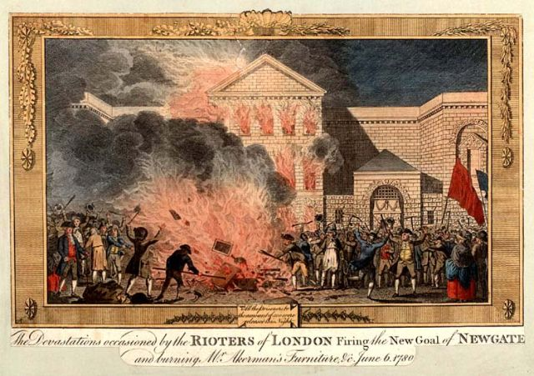
Thornton, Rioters at Newgate (1780)
London has also been envisioned as a place of disorder, illicit delight and unruliness. This week we explore the crime and punishment of Londoners, using the Old Bailey Online to discover how theft, prostitution and other crimes were punished. We will also assess how events like the Gordon Riots were informed by changing social trends and radical currents, the effects of Romanticism and the French Revolution on Londoners, and the emergence of the police.
Indicative reading:
Peter Ackroyd, London: The Biography, Chapters 24, 28-29.
Clive Bloom, Violent London: 2000 Years of Riots, Rebels and Revolts (Basingstoke: Palgrave Macmillan, 2010), Chapter 6.
David A. Campion, ‘“Policing the Peelers”: Parliament, the public and the Metropolitan Police, 1829-33 in Matthew Cragoe & Anthony Taylor, eds., London Politics, 1760-1914 (Basingstoke: Palgrave, 2005)
Peter Linebaugh, The London Hanged: Crime and Civil Society in the Eighteenth Century (London: Verso, 2006), Chapter 1.
Old Bailey Online: link here. A seminar search exercise will be set one week before.

4. Thames, Trade and Travel
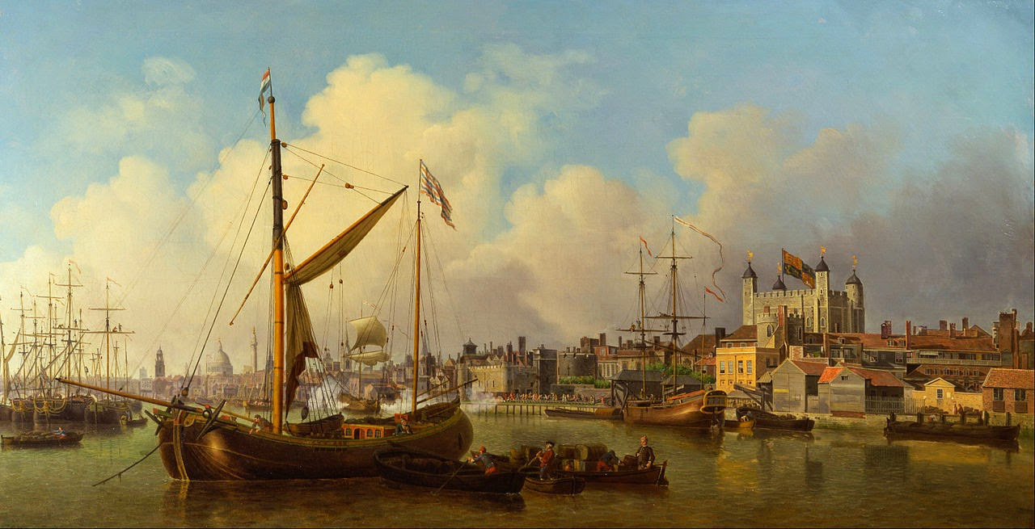
Samuel Scott, Thames (1771)
The Thames has placed a decisive role in London’s history from its earliest development into a bustling imperial trading power. This week we explore London’s relation with water, from river crossings and travel to Roman shrines, sewage and now-subterranean rivers. We will focus on the role of the river in the development of London as an imperial centre, from the build-up of the Royal Navy at Greenwich to the development of the docks and the East End around it. For the seminar we will take a walking tour from Greenwich to the Isle of Dogs.
Indicative reading:
Peter Ackroyd, Thames: Sacred River (London: Chatto & Windus, 2007), chapters 24-25.
Gustave Doré and William Blanchard Jerrold, London: A Pilgrimage (London: Anthem, 2006), chapter 3 “The Docks”.
Lucy Inglis, Georgian London, chapter 8 “The River Thames”.
Andrea Warwick, “Reading the Thames: An Introduction”. Literary London: Interdisciplinary Studies in the Representation of London, 5.1 (March 2007). http://www.literarylondon.org/london-journal/march2007/warwick.html
Virginia Woolf, “The Docks of London” (1931), in The London Scene (London: Hogarth, 1982).

5. Exploring the Nocturnal City
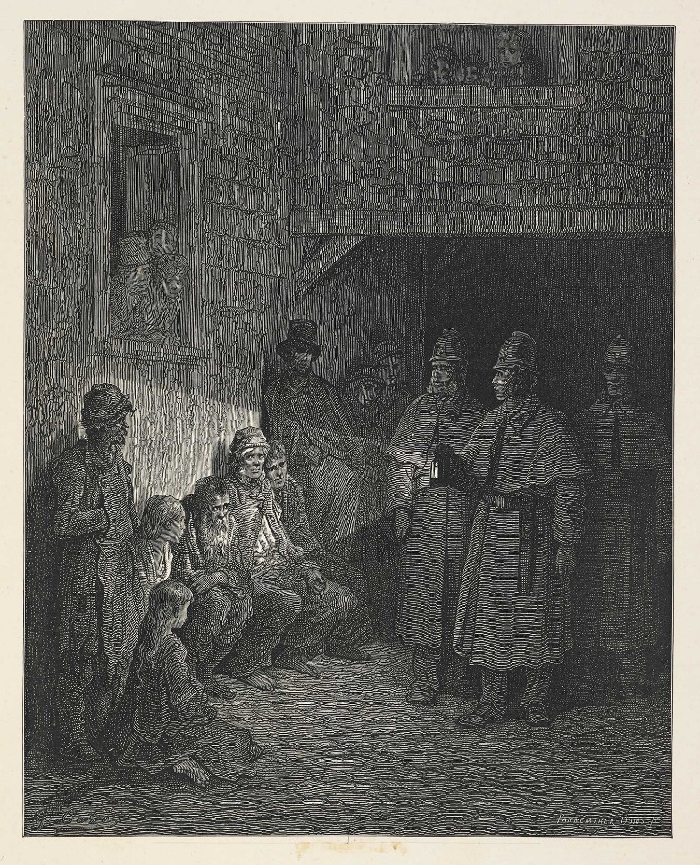
From Doré, London: A Pilgrimage (1872)
London has also had a reputation as a ‘City of Dreadful Night’, but while some have sought to reform its nightmarish, disorderly qualities, others have documented its peculiar world and inhabitants, or found solace and pleasure in night-walking. This week we turn to a developing genre of urban exploration and reporting. We will read and discuss Victorian social explorers like Charles Dickens, James Greenwood, William Booth, Arthur Morrison and Jack London. You will also be encouraged to journey out into an unknown part of London and document your findings as part of your formative assessment.
Indicative reading:
Matthew Beaumont, Nightwalking, chapter 11.
James Greenwood, “A Night in a Workhouse” (1866), available here.
William Booth, In Darkest England and the Way Out (1890), chapter 5. Available here.
Jack London, People of the Abyss (1902), chapters 1, 6 and 10. Available here.
Kurt Tetzeli Von Rosador, ‘Into darkest England: discovering the Victorian urban poor’, Journal for the Study of British Cultures 4:1-2 (1997), pp. 129-44
Anthony S. Wohl, ‘The Bitter Cry of Outcast London’, International Review of Social History, vol. 13 (1968) pp. 189-245

6. Poverty and Social Reform
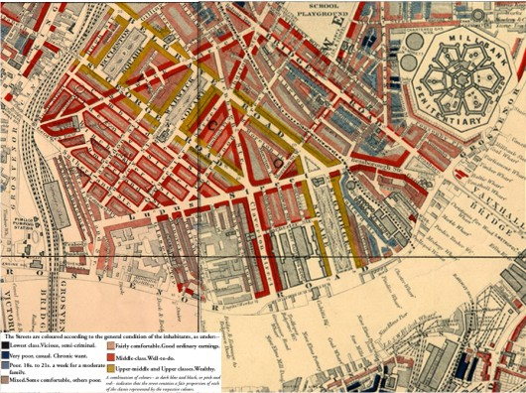
Pimlico, from Booth's survey of London, 1889
London’s population exploded over the 19th century, with many living in poverty and unemployment. In this class we explore the works of two social reformers, Henry Mayhew and Charles Booth, who sought to investigate and document lives of ordinary Londoners. We assess their varying attempts to characterise London and its inhabitants, their different motivations and moral views, as well as the context of urban philanthropic movements. In our seminars we will follow one of Booth’s survey notebooks through Whitechapel and the ‘Old Nichol’ in Shoreditch, reflecting on the changes between Booth’s world and our own.
Indicative reading:
Charles Booth, Life and Labour of the People in London (1903). Available online here. Please read Volume I, chapters 1-3. (You don’t need to study the tables in depth)
David R. Green, ‘A map for Mayhew's London: the geography of poverty in the mid-19th century’, London Journal, vol. 11 (1985), pp. 115-26
Henry Mayhew, London Labour and the London Poor (1861). Available online here. Please read “Front Matter” and any two entries of your choice.
David Reeder, ‘Representations of metropolis: descriptions of the social environment in Life and Labour’, in David Englander & Rosemary O'Day, eds. Retrieved riches: social investigation in Britain, 1840-1914 (Aldershot: Scolar Press, 1995), pp. 323-38
LSE Booth Archive: browse notebooks and maps here. Excerpts covering Old Nichol and Shoreditch will be provided a week before class.

7. Suburban Expansion
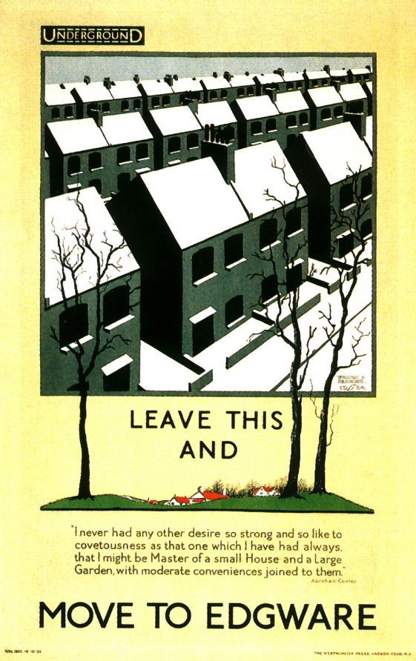
William A. Kermode, London Underground poster (1924)
New housing developments, aided by new affordable public transport, saw London profoundly expand outward from the early 20th century. We explore the new world of suburbia, and the kinds of cultural tensions and opportunities that emerged with it. While some expressed anxieties about mass conformity (be it Orwell, or the New Survey of London Life and Labour), others welcomed its opportunities. We will explore the progressive, modern new council house-building of the LCC estates at Becontree, Downham and elsewhere, as well as the creation of ‘Metro-Land’, watching a short film from the poet John Betjeman.
Indicative reading:
John Carey, ‘The Suburbs and the Clerks’, in The Intellectuals and the Masses: pride and Prejudice among the Literary Intelligentsia, 1880-1939 (London: FaberL, 1992)
Lynne Hapgood, Margins of Desire: The Suburbs in Fiction and Culture, 1880-1925 (Manchester: Manchester University Press, 2005), Introduction.
Alan Jackson, Semi-Detached London: Suburban Development, Life and Transport, 1900-39 (London, 1973), chapter 6.
George Orwell, Coming up for Air (London: Penguin, 2000 [1931]), part 1 chapter 2.
Paul Oliver, Ian Davis and Ian Bentley, Dunroamin: The Suburban Semi and Its Enemies (London: Pimlico, 1994), chapter 1.

8. London at War
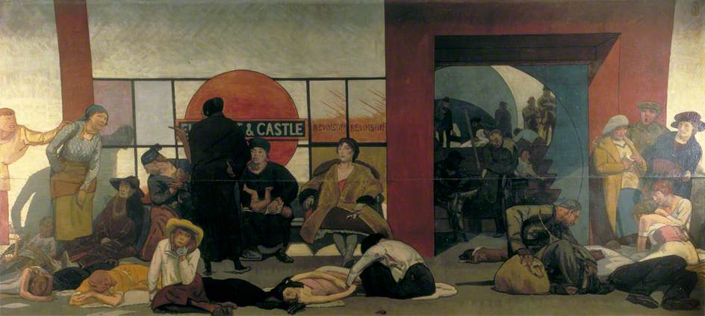
Walter Bayes, The Underworld (1918)
London was subject to profound destruction and transformation in both the First and Second World Wars. We explore the effects of war on social relations, from the demise of domestic service and women entering the workplace (and being able to vote) to the effects of shell-shock and unemployment on men returning home. Primary source material (testimonies, films) are contrasted with depictions like Virginia Woolf’s Mrs Dalloway to explore how some envisioned a new world rising from the city’s ashes. For the seminar, we will visit the bomb-damaged church of St Dunstan’s and explore the area later rebuilt as the Barbican, using the Bombsight WW2 bomb census app.
Indicative reading:
Peter Ackroyd, London: The Biography, chapter 76.
Peter Leese, ‘Problems Returning Home: The British Psychological Casualties of the Great War’ The Historical Journal, 40.4 (Dec. 1997), pp. 1055-67.
Jerry White, Zeppelin Nights: London in the First World War (London: Bodley Head, 2014), chapter 13.
Virginia Woolf, Mrs Dalloway (Oxford: Oxford University Press, 2008 [1925])
Philip Zeigler, London At War, 1939-1945 (London: Pimlico, 2002), Chapter 16.
Bombsight WW2 Bomb Census and app – link here.

9. Immigration and Empire
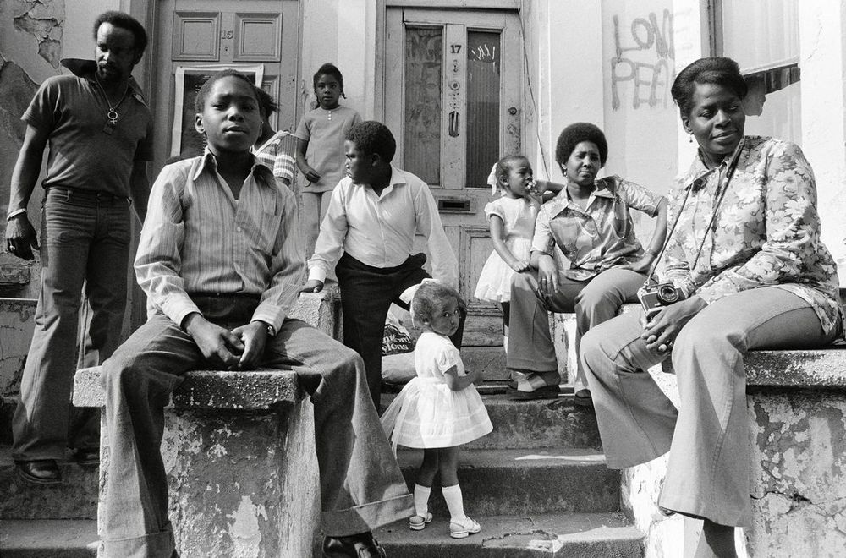
Chris Steele-Perkins, Notting Hill, 1973
After WW2 London underwent major reconstruction, and British subjects from across the Empire were recruited to fill needed vacancies in transport, healthcare and manufacturing. London has a history of migrant communities, but many new arrivals were subject to racism and discrimination. We explore the experiences of Commonwealth migrants like those of the “Windrush Generation” in literature and film, and identify newly-available source material from the Black Cultural Archives to explore how landmarks of identity and community transformed.
Indicative reading:
Peter Fryer, Staying Power: The History of Black People in Britain (London: Pluto, 2010), chapter 11.
David Olusoga, Black and British: A Forgotten History (London: Macmillan, 2016), chapter 13.
Mike and Trevor Phillips, Windrush: The Irresistible Rise of Multi-Racial Britain (London, Harper Collins, 1998), chapters 4-6.
Bill Schwarz, ‘Black Metropolis, White England’, in Nava and O'Shea (eds.), Modern Times; Reflections on a Century of English Modernity (London, 1996)
Samuel Selvon, The Lonely Londoners (London: Penguin, 2006 [1956])

10. London Calling
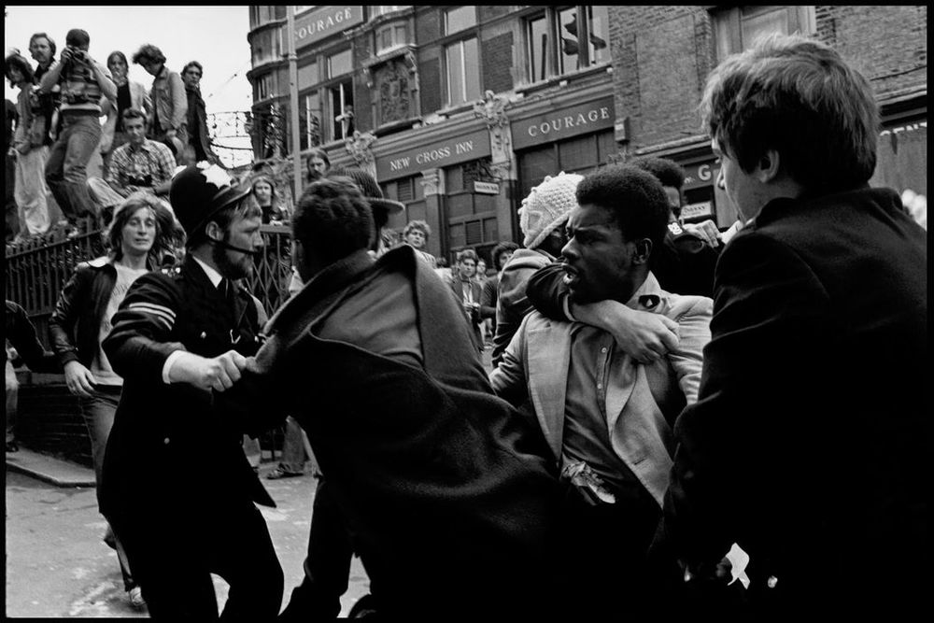
Chris Steele-Perkins, Battle of Lewisham, 1977
By the latter half of the 20th century, London was undergoing profound social and economic change, with widescale deindustrialisation, the closure of its historic docks, and its elevated role as the heart of empire gone. In our final class we explore new social movements in the 1960s and 70s, from the youth subcultures of ‘Swinging London’ to student protests, the rise and fall of the National Front, resistance against racism, and a new appreciation of the politics of culture and the growth of multiculturalism.
Indicative reading:
Nigel Copsey, Anti-Fascism in Britain. Second Edition (London and New York: Palgrave Macmillan, 2017), chapter 4.
Anandi Ramamurthy, ‘The politics of Britain’s Asian Youth Movements’, Race & Class, 48.2 (2006), pp. 38-60
Nick Thomas, ‘Challenging Myths of the 1960s: The Case of Student Protest in Britain’, Twentieth Century British History, 13.3 (2002), pp. 277–297.
J.D. Taylor, ‘The Party’s Over? The Angry Brigade, the Counterculture, and the British New Left, 1967-1972’, The Historical Journal, 58.3 (2015), pp. 877-900.
Jerry White, London in the Twentieth Century, chapter 4.

Assessment

Formative
There is one formative assignment that you need to complete in preparation for your summative assignments.
Formative assignment 1 = practice blog post, writing about an identified London landmark, of around 1500 words.
Deadline for submitting your formative assignment: 1pm on Thursday 16th November 2017

Summative
This module is assessed through two summative assignments, using different methods, one of which is worth 30% of your final grade and the other 70%. You MUST submit both assignments in order to pass the module.

Summative Assignment 1
(30%) = summative blog post (different to your formative post)
Year 2 & Study Abroad students: word limit = 1250 words
Year 3 students: word limit = 1500 words
Deadline for submitting your summative blog post: 1pm on Thursday 7th December 2017
This is a blogging assignment which is designed to engage students with practically studying London history through first-hand experiences, to assess their ability to evaluate the contemporary resonances of urban history, and to develop transferable skills in writing and publishing online.

Summative Assignment 2
(70%) = summative essay
Year 2 & Study Abroad students: word limit = 2500 words
Year 3 students: word limit = 3000 words
Deadline for submitting your summative essay: 1pm on Thursday 11th January 2018
This is an essay which is designed to assess the student’s overall comprehension and achievement of the learning outcomes in a conclusive manner at the end of the module.
All students will be expected to set their own question or title for their summative essay. This process must be undertaken in collaboration with the module tutor and you must have your summative essay question or title approved in advance.

Please note
All summative assignments must be submitted online via the Year 2/Year 3 Summative Coursework Submission VLE.
You must ensure that you carefully follow all the instructions; failure to correctly submit your assignment will result in a fail grade of zero.
You must ensure that your assignments are submitted before the deadline; the VLE records your submission time to the second and if your assignment is even a few seconds late it may not be marked.
If you experience extenuating circumstances which you feel are delaying or interfering with your ability to submit any of your assignments, you should speak to your personal tutor as soon as possible; do not leave it until the work is late.

Learning outcomes
All students (levels 5 & 6) undertaking and completing this module will be able to:
- Demonstrate and apply knowledge and understanding of London and its history from the sixteenth to the twentieth centuries.
- Evaluate and situate London history into national and international contexts.
- Understand and explain the relationship between London, its history and the built environment.
- Critically analyse heritage sites and evaluate different methodological approaches to urban history.
- Appraise and evaluate relevant secondary and historiographical literature.
- Employ selected primary written and visual sources.
- Collect, through practical engagement, original research material and synthesise it into suitable content for online publication.
- Write and creatively disseminate research findings via online publication platforms.
In addition, level 6 students undertaking and completing this module should:
- Identify, locate, evaluate and employ a range of primary source material.
- Critically engage with and account for major points of debate regarding urban history.

Transferable skills
- Retrieve and organise information from different sources, and carry out research with limited guidance.
- Develop critical judgement to produce logical, structured analyses and arguments supported by relevant evidence.
- Communicate information, arguments and ideas cogently and effectively using an online platform and in essays.
- Work to briefs and deadlines, including managing concurrent projects.
- Work constructively in groups, improving confidence and communication skills
- Ability to confidently identify and utilise primary source material, including in special collections and historical archives.

