Life and Death in London: A Walk Through the City

Bedlam
In 1247 the asylum was founded at Bishopsgate, just outside the London wall, by Simon FitzMary, former sheriff of London; it was then known as the Priory of St. Mary of Bethlehem (from which sprang the variant spellings Bedlam and Bethlem), established by the Bishop-elect of Bethlehem, the Italian Goffredo de Prefetti. Bedlam was mentioned as a hospital in 1329, and some permanent patients were accommodated there by 1403 six male inmates who were “mente capti”, a Latin term indicating insanity. The visitation also noted the presence of four pairs of manacles, eleven chains, six locks and two pairs of stocks, presumably used to restrain the most violent inmates. In c.1450 the Mayor of London described Bedlam as a “place [where may] be found many men that be fallen out of their wit. And full honestly they be kept in that place; and some be restored onto their wit and health again. And some be abiding therein for ever, for they be fallen so much out of themselves that it is incurable unto man”. Little is known of the treatment of the insane for much of the medieval period, though mechanical restraint, a meagre diet and solitary confinement are likely to have been common practices.
As a dependent house of the Order of Saint Bethlehem in Clamecy, Bethlem was vulnerable to seizure by the crown and this occurred in the 1370s when Edward III took control. The purpose of this appropriation was, in the context of the Hundred Years' War between France and England, to prevent funds raised by the hospital from enriching the French monarchy via the papal court.
In 1546 the Lord Mayor of London, Sir John Gresham, petitioned the crown to grant Bethlem to the city. This petition was partially successful and Henry VIII reluctantly ceded to the City of London "the custody, order and governance" of the hospital and of its "occupants and revenues". This charter came into effect in 1547. The crown retained possession of the hospital while its administration fell to the city authorities. Following a brief interval when it was placed under the management of the governors of Christ's Hospital, from 1557 it was administered by the governors of Bridewell, a prototype house of correction at Blackfriars. Having been thus one of the few metropolitan hospitals to have survived the dissolution of the monasteries physically intact, this joint administration continued, not without interference by both the crown and city, until incorporation into the National Health Service in 1948.
In the 17th and 18th centuries Bedlam was open to fee-paying spectators, but this disruptive practice was ended in 1770. The hospital was moved in 1675–76 to Moorfields (just north of the ancient London wall at Moorgate), in 1815 to St. George’s Fields (now in Southwark), and in 1930 to Monks Orchard, Beckenham.

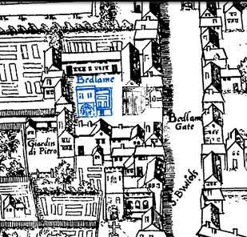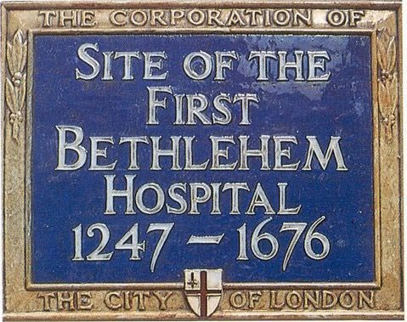
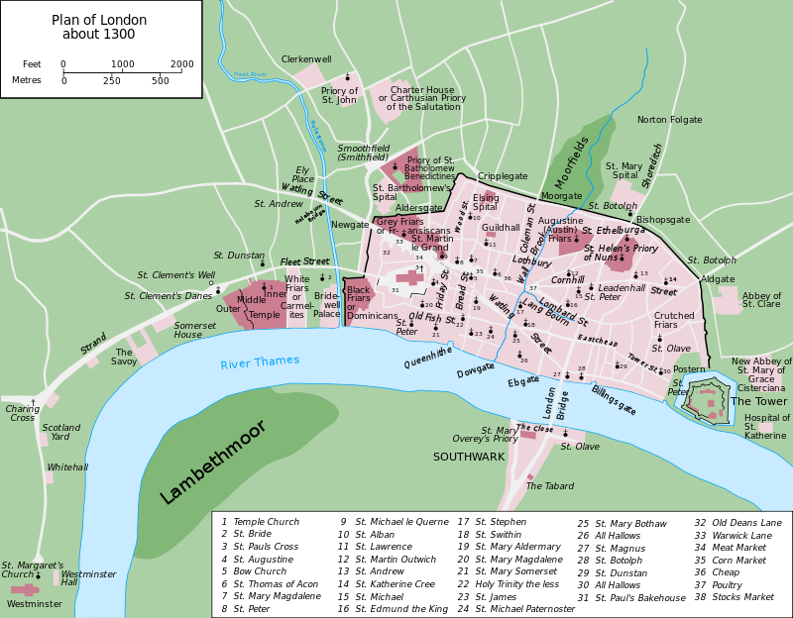
London, 1300
2. Crossrail, exhumations
Archaeological excavations here have uncovered 3000 bodies as part of the Crossrail extension, which are being scientifically analysed, and have found details of 5000 people buried in the 16th and 17th centuries on this site, many from mass plague pits, some inmates of Bedlam. According to the research Dr John Lamb (also known as Lam or Lambe), an astrologer and advisor to the First Duke of Buckingham, is among those buried at the site. Lamb was said to have been stoned to death by an angry mob outside a theatre in 1628 following allegations of rape and black magic. Others identified in the research include victims of riots by ‘Fanatiques,’ noted in the diaries of Samuel Pepys in January 1661.
Plague was the most common listed form of death, followed by infant mortality and consumption. The burial ground was established in 1569 to help parishes cope with overcrowding during outbreaks of plague and other epidemics. Crossrail workers recently discovered the gravestone of Mary Godfree who died in September 1665, as a result of the ‘Great Plague’ which peaked that year. To date Crossrail has found more than 10,000 artefacts spanning 55 million years of London’s history across over 40 construction sites.
The Bedlam burial ground here was the first not associated with a parish church, and was in use from 1569 to at least 1738. Many buried here were on the fringes of society, not associated with any parish church or who could not afford a church burial. Common occupations from the records include servants, maids, tailors, shoemakers and watermen, and numerous ethnicities.
3. The Second Bethlem Hospital: 1676-1815
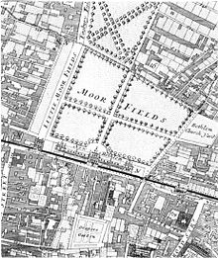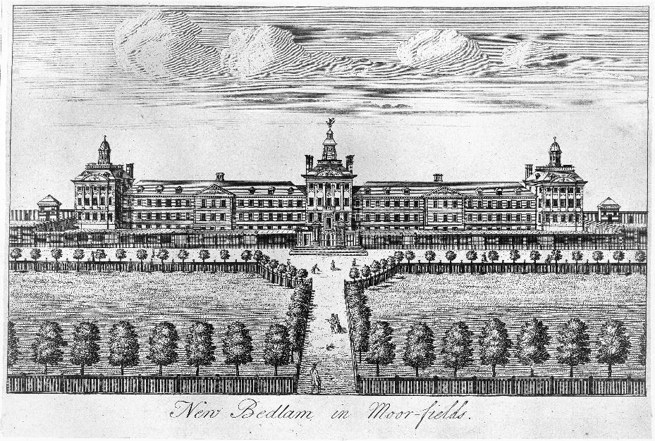
1598 - committee of inspection found that during the period of Sleford's keepership the hospital buildings had fallen into a deplorable condition with the roof caving in, the kitchen sink blocked up and reported that “...it is not fitt for anye man to dwell in wch was left by the Keeper for that it is so loathsomly filthely kept not fitt for anye man to come into the sayd howse”
1632 and 1633 - Royal commissioners investigate scandals in the hospital.
1693. — A nurse to be hired "as an experiment"
1699 - Report of Bethlem committee on the discreditable appearance of the wards on public holidays
1700. — An out-patient department instituted. The word "patient"
1725-1734. — Wards for male and female incurable patients constructed.
1732-1733. — Hogarth paints " Bedlam " — the eighth scene of the Rake's Progress."
1766. — The doors of the hospital to be locked on public holidays against all visitors.
1776 — Admission of visitors henceforth to be only by ticket, and accredited visitors to be accompanied by an attendant
1800. — Architect reports the hospital to be in an insecure condition.

1815 and 1816. — Parliamentary inquiries into the treatment of patients. 1815 - report to the House of Commons. Dr. Connolly reported that he found in one of the side-rooms; "about ten patients each chained by one arm or leg to the wall, each wearing a sort of dressing gown with nothing to fasten it.
The 1598 visitation by the Governors had observed that the hospital was “filthely kept”, and a later inspection found inmates actually starving. Dr. Hilkiah Crooke appointed master in 1619. Rarely attended to the hospital, embezzled hospital resources. Typically he and his steward either took the goods and foodstuffs that was donated and purchased by the hospital for the inmates for his own use, or sold it to the inmates. (If they didn’t have the funds to buy, they would often go hungry. Stated he cured 17 ‘lunatics’, and was dismissed in 1633.
Famous patients: Urban Metcalf – ex-patient who published, in 1818, a pamphlet which exposed both bullying and pilfering at Bethlem Hospital. He described the case of a man named Popplestone, “whose leg rotted off as he was chained up for such a lengthy period that the metal cut into his flesh”, and the case of another patient murdered. James Norris, an American marine, immobilised for 12 years, with “a stout iron ring ...riveted round his neck”, from which a short chain passed through a ring made to slide upwards and downwards on an upright massive iron bar, more than six feet high, inserted into the wall. He died after his intestines burst as a result of this.
The playwright Nathaniel Lee was incarcerated there for five years from 1684, reporting that: "They called me mad, and I called them mad, and damn them, they outvoted me. Mary Frith, a “a notorious pickpocket and fence of the English underworld.”
Why did they visit? Visiting was defended by some commentators as a form of moral instruction, as it illustrated the dangers of immorality and vice which could, in popular belief, lead to madness. As one spectator commented, “[there is no] better lesson [to] be taught us in any part of the globe than in this school of misery…From so humbling a sight we may learn to moderate our pride, and to keep those passions within bounds, which if too much indulged, would drive reason from her seat, and level us with the wretches of this unhappy mansion”. The alms was used to help support the work of the hospital. Patricia Alledge argues to justify some of its caring work. An 18th century observer recorded how on one occasion, “a hundred people at least [were] . . . suffered unattended to run rioting up and down the wards, making sport and diversion of the miserable inhabitants, [some of whom were] provoked by the insults of this holiday mob into furies of rage”.
The most common treatment in this system was blood-letting, but patients at Bedlam were also subject to forcibly induced vomiting, scarification and purgation. Such was the violence of the standard medical course that patients were regularly discharged or refused admission if they were deemed unfit to survive the physical onslaught. Alexander Cruden, a writer who was briefly incarcerated in Bedlam, said bitterly of the physicians there: “but is there so great Merit and Dexterity in being a mad Doctor? The common Prescriptions of a Bethlemitical Doctor are a Purge and a Vomit, and a Vomit and a Purge over again, and sometimes a Bleeding, which is no great mystery”.
4. Salters Hall
The Salters' Company received its first licence from Richard II in 1394, but like other Livery Companies, was probably in existence prior to 1066. It is one of London’s twelve main livery companies. Since before the Romans, the Anglo Saxons had developed methods of extracting salt and the importance of salt was well established. Roman soldiers were given salt rations and this “Sal” is the origin of the word “salary”. A soldier failing in battle or falling asleep at his post was “not worth his salt”. By the fourteenth century, salt was an essential commodity in England. It was used mainly for preserving meat and fish before the advent of tin cans and refrigeration. Other uses included any operation where ‘chemical’ action was required, such as cleaning, dyeing fabric, bleaching, degreasing, dehairing and softening leather and in the formulation of medicines and ointments. Today it is associated with chemistry and most of its work is philanthropic.
5. St Giles Cripplegate and Barbican
Church founded in 11th century, and several times. Oliver Cromwell married here in 1620, and buried is John Foxe of The Book of Martyrs (1587), and John Milton. John Graunt records that in St Giles Cripplegate, 3988 died, of which from plague, 2338. Graunt’s Natural and Political Observations Made upon the Bills of Mortality (1662/1663) used analysis of the bills of mortality (weekly statistics of deaths) in early modern London as Charles II and other officials attempted to create a system to warn of the onset and spread of bubonic plague in the city. Though the system was never truly created, Graunt's work in studying the rolls resulted in the first statistically based estimation of the population of London. His work ran to five editions by 1676. Causes of death included bleeding, burnt and scalded, drowned, excessive drinking, frighted, grief, hanged themselves, kil’d by several accidents, murdered, poisoned, smothered, shot, starved, vomiting.
‘Before we pass from hence, we shall offer to consideration the inequality of Parishes in, and about London, evident in the proportion of their respective Burials; for in the same year were buried in Cripple-gate-Parish 1191, that but twelve died in Trinity-Minories, St. Saviour's Southwark, and Botolph's Bishop-gate, being of the middle size, as burying five and 600 per Annum; so that Cripple-gate is an hundred times as big as the Minories, and 200 times as big as St. John the Euangelist's, Mary-Cole-church, Bennet's Grace-church, Matthew-Friday-street, and some others within the City’.
6. Barbican
Named after an outer fortification of the city, possibly a watchtower, pulled down in 1267 according to Stow by Henry III. On 29 December 1940 a 35-acre was destroyed by incendiary bombs, including all streets from Moorgate to Aldersgate Street, with the church ruined, only walls and tower left standing. The site was compulsorily bought in 1958, and the site here from a 1959 design by Chamberlin, Powell and Bon, comprising 2014 flats housing 6500 people, building beginning in 1963 and taking several years.
7. Barber hall
The Fellowship of Surgeons merged with the Barbers' Company in 1540, forming the Company of Barbers and Surgeons, but after the rising professionalism of the trade broke away in 1745 to form what would become the Royal College of Surgeons.
The Company no longer retains an association with the hairdressing profession, and principally acts as a charitable institution for medical and surgical causes. In modern times, between one-third and one-half of the Company's liverymen are surgeons, dentists or other medical practitioners.
The first mention of the Barbers' Company occurs in 1308, when Richard le Barbour was elected by the Court of Aldermen to keep order amongst his fellows. Barbers originally aided monks, who were at the time the traditional practitioners of medicine and surgery, because Papal decrees prohibited members of religious orders themselves from spilling blood. In addition to haircutting, hairdressing, and shaving, barbers performed surgery: neck manipulation; cleansing of ears and scalp; draining/lancing of boils, fistulae, and cysts with wicks; bloodletting and leeching; fire cupping; enemas; and the extraction of teeth.
8. London wall
In the early 4th century, the city had 3 miles of walls, 8 feet thick and 20 feet wide, enclosing a semi-circular area of 236 acres. In medieval Europe it had an additional gate at Moorgate.
9. Wesley monument and Museum of London
10. Little Britain
Named after the Dukes of Brittany, who had a house here before the 16th century. From 1575-1725 it was popular with booksellers, and in 1711 the Spectator was first printed here. Both Samuel Johnson and Ben Franklin lodge here, and Dickens places the dismal offices of Mr Jaggers, the lawyer in Great Expectations, here.
11. St Bart's hospital
Barts was founded in 1123 by Rahere (died 1144, and entombed in the nearby Priory Church of St Bartholomew the Great), a favourite courtier of King Henry I. The Dissolution of the Monasteries did not affect the running of Barts as a hospital, but left it in a precarious position by removing its income. It was refounded by King Henry VIII in December 1546, on the signing of an agreement granting the hospital to the Corporation of London. The hospital became legally styled as the ‘House of the Poore in West Smithfield in the suburbs of the City of London of Henry VIII's Foundation’. It was here that William Harvey conducted his research on the circulatory system in the 17th century, Percivall Pott and John Abernethy developed important principles of modern surgery in the 18th century, and Mrs Bedford Fenwick worked to advance the nursing profession in the late 19th century.
Barts is the oldest hospital in Britain still providing medical services which occupies the site it was originally built on, and has an important current role as well as a long history and architecturally important buildings. The so-named Henry VIII entrance to the hospital continues to be the main public entrance; and the statue of King Henry VIII above the gate is the only remaining statue of him in London.
Its main square was designed by James Gibbs in the 1730s. Of the four original blocks only three survive; they include the block containing the Great Hall and two flanking blocks that contained wards. The first wing to be built was the North Wing, in 1732, which includes the Great Hall and the Hogarth murals. The South Wing followed in 1740, the West in 1752 and finally the East Wing in 1769. In 1859, a fountain was placed at the square's centre with a small garden.
12. St Bartholomew the Great
Built by courtier, jester and cleric Rahere after an attack of malarial fever on a pilgrimage to Rome. His vision tells him to build a church and hospital on this spot. It quickly becomes popular as a place of pilgrimage, and the hospital and fair are established. John Betjeman lived opposite on Cloth Fair, and called the inside of the church the finest Norman interior in London.
13. Smithfield
In the Middle Ages, it was a broad grassy area known as Smooth Field, located beyond London Wall stretching to the eastern bank of the River Fleet. Smithfield's meat market dates from the 10th century, and is now London's only remaining wholesale market in continuous operation since medieval times. The meat market is expanded here from 1869, when the Newgate Street market is closed. Smithfield Market, a Grade II listed-covered market building, was designed by Victorian architect Sir Horace Jones in the second half of the 19th century, and is the dominant architectural feature of the area.
Nearby and to the north of this demesne, the Knights Hospitaller established a Commandery at Clerkenwell dedicated to St John in the mid-12th century, and in 1194 received a Charter from King Richard I granting the Order formal privileges. Later Augustinian canonesses established the Priory of St Mary, north of the Knights of St John property.
By the end of the 14th century, these religious houses were regarded by City traders as interlopers — occupying what had previously been public open space nearby one of the City gates. On numerous occasions vandals damaged the Charterhouse, eventually demolishing its buildings. By 1405, a stout wall was built to protect the property and maintain the privacy of the Order, particularly its church where men and women alike came to worship. The religious houses were dissolved in the Reformation, and their lands broken up.
In 1374 Edward III held a seven-day tournament at Smithfield, for the amusement of his beloved Alice Perrers. Possibly the most famous medieval tournament at Smithfield was that commanded in 1390 by Richard II. Jean Froissart, in his fourth book of Chronicles, reported that sixty knights would come to London to tilt for two days, "accompanied by sixty noble ladies, richly ornamented and dressed".[28] The tournament was proclaimed by heralds throughout England, Scotland, Hainault, Germany, Flanders and France, so as to rival the jousts given by Charles of France at Paris a few years earlier, upon the arrival of his consort Isabel of Bavaria. Geoffrey Chaucer supervised preparations for the tournament as a clerk to the King. Along with Tyburn, Smithfield was for centuries the main site for the public execution of heretics and dissidents in London. The Scottish nobleman Sir William Wallace was executed in 1305 at West Smithfield. The market was the meeting place prior to the Peasants' Revolt and where the Revolt's leader, Wat Tyler, was slain by Sir William Walworth, Lord Mayor of London on 15 June 1381.
Religious dissenters (Catholics as well as other Protestant denominations such as Anabaptists) were sentenced to death in this area during the Crown's changing course of religious orientation started by King Henry VIII. About fifty Protestants and religious reformers, known as the Marian martyrs, were executed at Smithfield during the reign of Mary I.
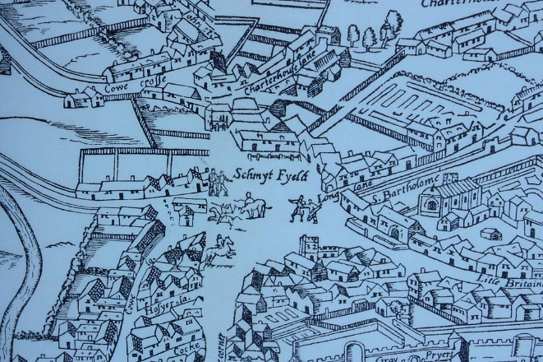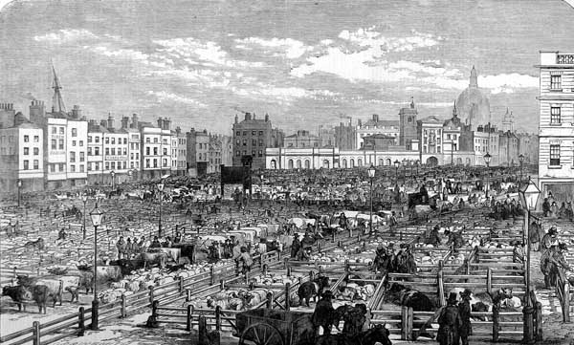
L. Smithfield from the "woodcut" map of c. 1561, illustrating its proximity with open fields to the west, and cattle pens by the City. R. Smithfield Market, 1855.
14. Charterhouse
Site of a Carthusian Monastery, and the surviving buildings are now Sutton Hospital almshouses. Thackeray lodged here. It was used as a burial pit during the Black Death, Pardon Churchyard. A small chapel was here, and later from 1370 the monastery. The monks lived and worked alone, had no personal possessions and would not eat meat, and could only talk to each other on Sundays. Thomas More visits them. Later Thomas Cromwell has three priors executed for ‘treacherously machinating and desiring’ to deprive the king of his title after they request to discuss his supremacy with them. One of the prior’s arms was hung over the gate but it fell down three days later and was buried. Further monks were sent to Newgate and nine starved to death, and the last executed. After the ten monks had died, Henry VIII used it as a place to store tents, then it was given to an ally of Elizabeth.
Goswell Row – north is Mount Mills, which Defoe describes as a plague pit. Close might be ‘No Man’s Land’ graveyard, a huge burial spot thought to be near Clerkenwell or Farringdon.
15. St Lukes
The hospital was founded as St Luke's Hospital for Lunatics by City of London philanthropists with the intention of curing 'lunacy' and making treatment accessible to poorer people. The first patients were admitted in July 1751 to the converted Moorfields Foundry site. In 1786 it moved to a purpose-built site on Old Street, where it remained until 1916. From 1841 the hospital came under the London Commissioners in Lunacy, but by 1865 it was taking mainly middle class patients. It was built close to ‘Perilous Pond’, a famous healing spot
The first chief physician was Dr William Battie who was renowned as ‘an eccentric humorist’. He believed ‘the patients of this hospital shall not be exposed to publick view.’ Medical treatment consisted of cold plunge baths to shake lunatics out of their insanity. A system of non-restraint was professed, however manacles and other restraints were sometimes used.
In 1786 the hospital moved to Dance's purpose-built premises on Old Street, between Bath St and what is now the City Road roundabout. The building had a magnificent frontage of clamp brick, 500 feet (150 m) long, which had a central entrance, with the male wards to the left and female wards to the right. The building contained single cells for 300 patients, each with small windows set high in the wall, no heating, and loose straw on wooden bedsteads.
By 1865 it had a population of 150 to 160 patients, taken from the middle classes, its original purpose of supporting paupers having been abandoned. The proportion of cures at St. Luke's was 67 to 70 per cent compared to that of only 15 per cent at pauper lunatic asylums.
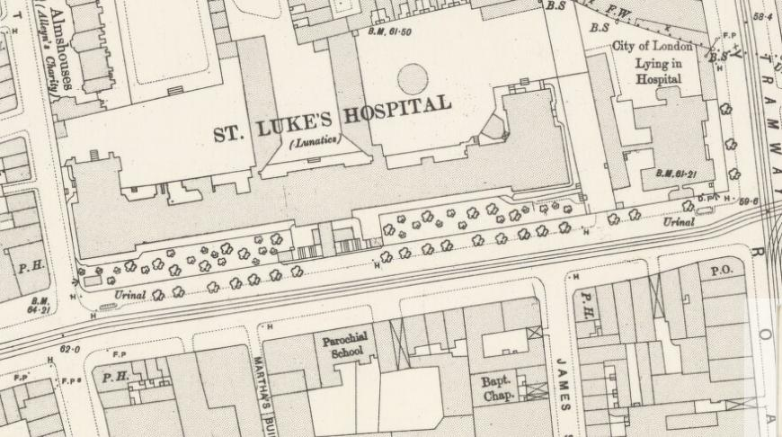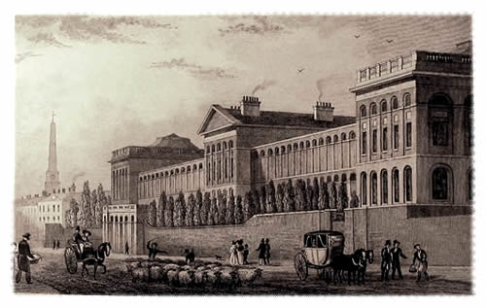
16. Peerloss Pond / Perilous Pond
It gained its name from many tragic drownings there of people using it as a swimming hole. It was also used by fishermen and wildfowlers.
In 1743 the pond was purchased by William Kemp, a jeweller, who developed it by enclosing it in stone edging and adding marble steps and a gravel bottom. He built a separate pond for fishing and renamed the site the more enticing Peerless Pool. The grounds were screened by trees and the pool was used as an ice rink in winter. Kemp imposed an annual admission charge of £1 10s. (or 1s. for day visitors).[1] The pool was 170 ft long x 108 ft wide and from 3–5 feet deep. It was London’s first outdoor public swimming pool. From 1790 there was also a small library and a bowling green attached. Around 1805, the lease was acquired by Joseph Watts who drained the fish pond and constructed Baldwin Street on that part of the site.
William Hone , the satirist, visited the pool in 1826 and described it thus: ‘Trees enough remain to shade the visitor from the heat of the sun on the brink. On a summer evening it is amusing to survey the conduct of the bathers; some boldly dive, others timorous stand and then descend step by step, unwilling and slow; choice swimmers attract attention by divings and somersets, and the whole sheet of water sometimes rings with merriment. Every fine Thursday and Saturday afternoon in the summer columns of Bluecoat boys, more than a score in each, headed by their respective beadles, arrive and some half strip themselves ‘ere they reach their destination. The rapid plunges they make into the Pool and their hilarity in the bath testify their enjoyment of the tepid fluid’.
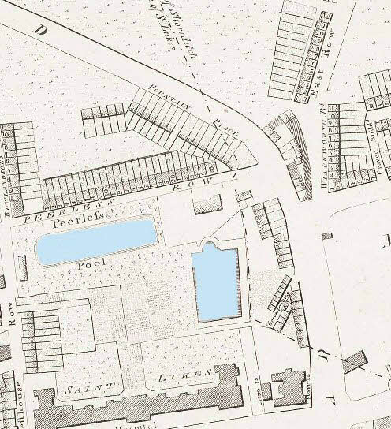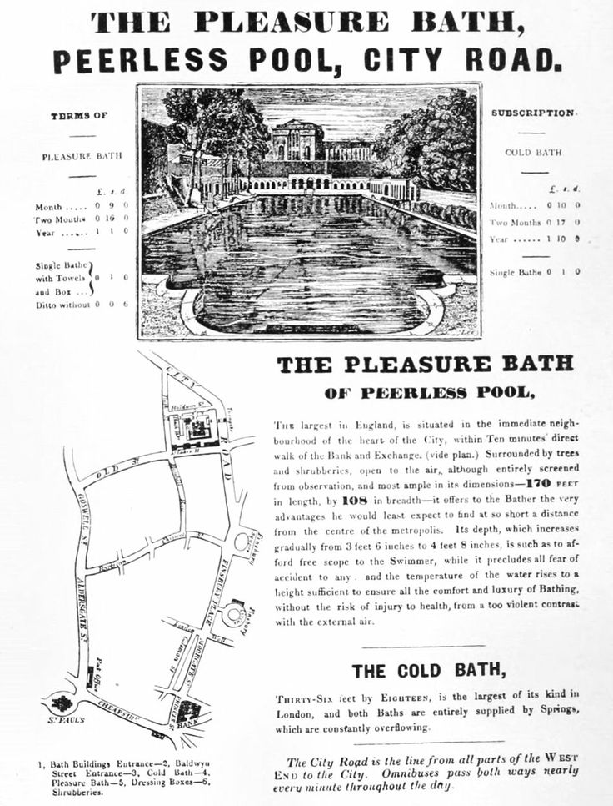
17. Whitecross
Named after a cross painted white which stood outside a house belonging to the Holy Trinity Priory, Aldgate, in the 13th century, and originally much longer, from Fore Street to Old Street until damage during WW2. Whitecross Street debtors prison stood at the corner with Fore Street (1813-70). In Victorian times a street market flourished, with Mayhew counting 150 stalls. Prison opened after a parliamentary campaign to separate debtors from criminals
18. Bunhill
Originally part of the fields of the manor of Finsbury. It was called Bone Hill before 1549, when cartloads of bones from the charnel house at St Pauls Churchyard were taken here. In mid-17th century the Corporation of London, which had leased the fields since 1315, decides to establish a burial ground for the plague, but it becomes used as an ordinary cemetery, particularly by Non-Conformists. The spiked gate in the north-east corner was built to deter bodysnatchers, and it was closed in 1854.
Blake’s London
I wandered through each chartered street,
Near where the chartered Thames does flow,
A mark in every face I meet,
Marks of weakness, marks of woe.
In every cry of every man,
In every infant's cry of fear,
In every voice, in every ban,
The mind-forged manacles I hear:
How the chimney-sweeper's cry
Every blackening church appals,
And the hapless soldier's sigh
Runs in blood down palace-walls.
But most, through midnight streets I hear
How the youthful harlot's curse
Blasts the new-born infant's tear,
And blights with plagues the marriage-hearse.

