Seminar Exercise: Old Bailey Archive
1. What is the value of the Old Bailey records? Are there any potential issues with them?
2. How many women were found guilty of infanticide between January 1700 and December 1750? How many men?
3. How do you explain the gender difference in relation to this crime? Did you notice anything about the punishments given out to men and women found guilty of infanticide?

Seminar Questions

1. Compare the following two images. What can we learn about changing attitudes to crime and punishment in London?

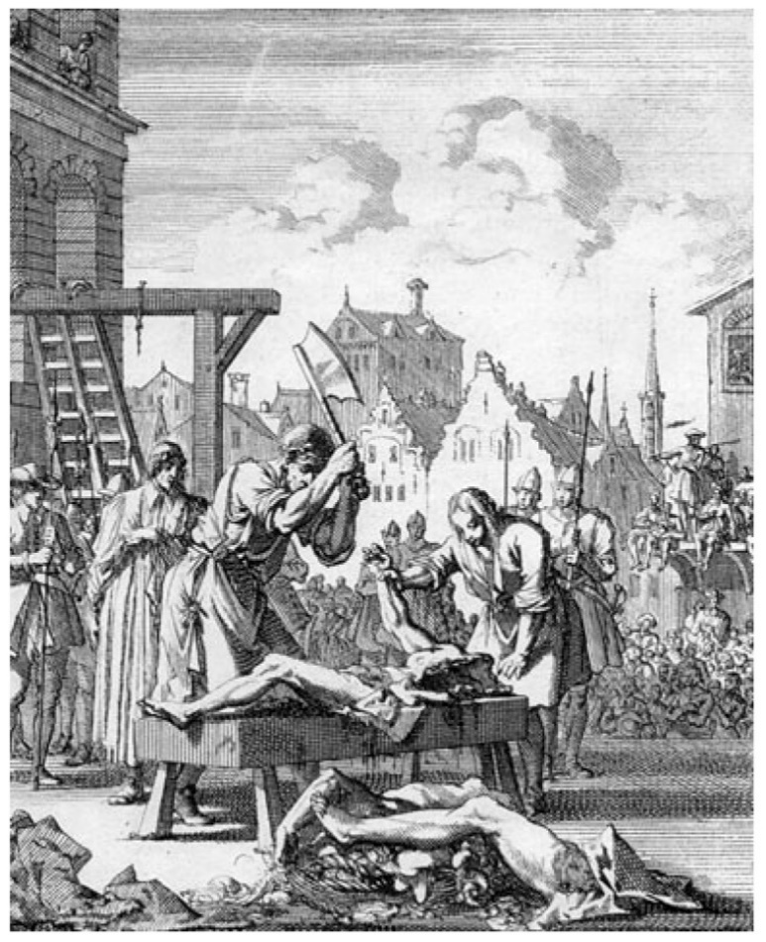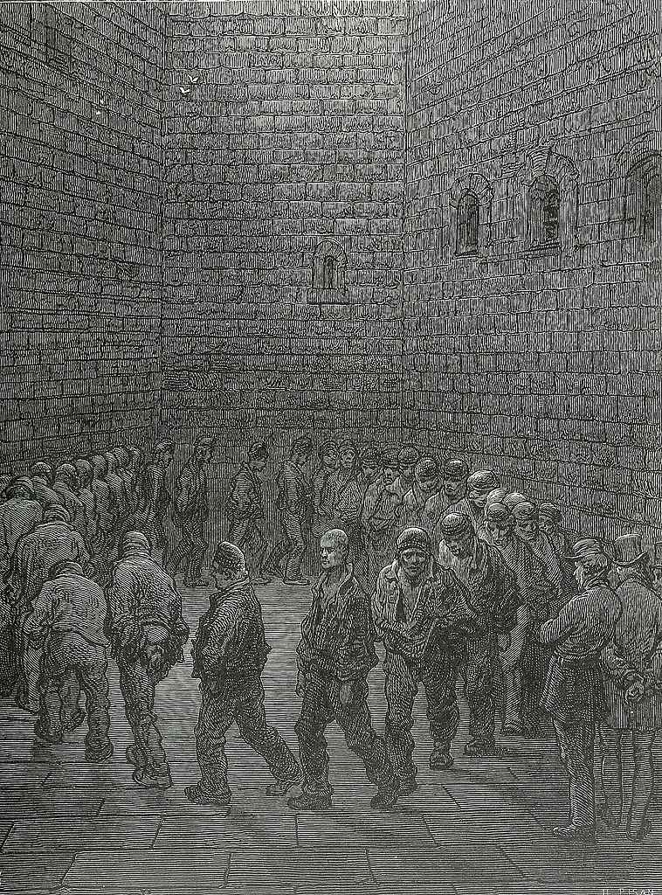
Left: Execution of Sir Thomas Armstrong, 1684; Right: Gustav Doré, Newgate – Exercise Yard, 1872

2. Compare the following two images. What can we learn about changing attitudes to justice and criminality in London?
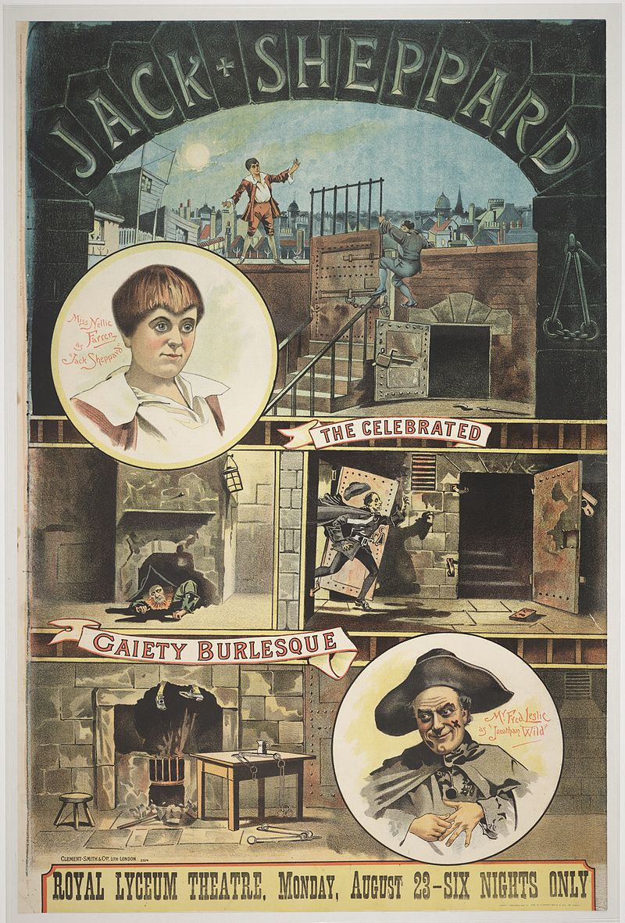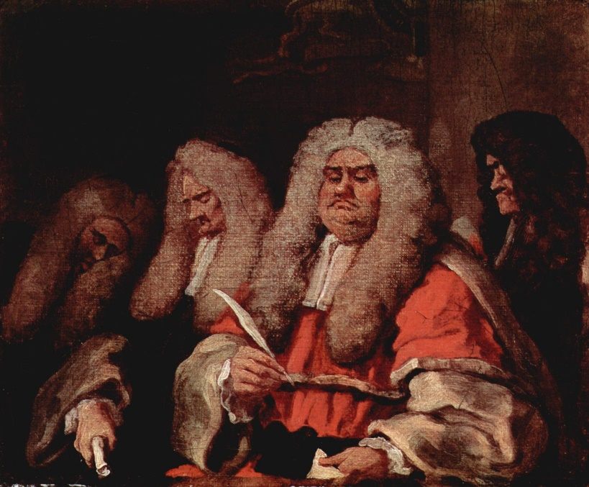
Left: Poster bill for Little Jack Sheppard, 1855; Right: Hogarth, The Bench, 1758

3. Compare the two poems. What can we learn about criminality and disorder in London from these?

‘I Have heard sundry men oft times dispute
Of trees, that in one year will twice bear fruit.
But if a man note Tyburn, 'will appear,
That that's a tree that bears twelve times a year.
I muse it should so fruitful be, for why
I understand the root of it is dry,
It bears no leaf, no bloom, or no bud,
The rain that makes it fructify is blood.
I further note, the fruit which it produces,
Doth seldom serve for profitable uses:
Except the skillful Surgeons industry
Do make Dissection of Anatomy.’
- John Taylor, “The Description of Tyburn”, 1630
‘Through all the Employments of Life
Each Neighbour abuses his Brother;
Whore and Rogue they call Husband and Wife:
All Professions be-rogue one another:
The Priest calls the Lawyer a Cheat,
The Lawyer be-knaves the Divine:
And the Statesman, because he's so great,
Thinks his Trade as honest as mine.’
- Peachum, Act I, air 1, from John Gay, The Beggar’s Opera (1728)

4. Choose one of the following landmarks, and explain its significance within London history: Evil May Day; the Gordon Riots; Tyburn Tree; Jack Sheppard; Newgate; or the Peelers.

