A Walk around Deptford and Greenwich
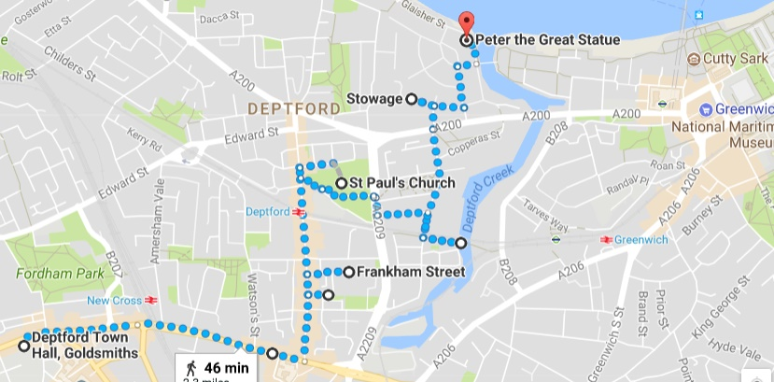
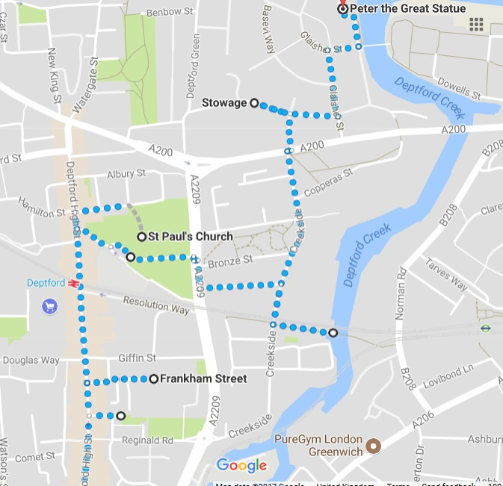
We start at Deptford Town Hall. The Town Hall for the new Council was built between 1903 and 1905, and for much of the 20th century was at the centre of local political and social life. In the First World War, the Town Hall was used as an enlistment centre. In a one week period in 1915, 750 men joined up there, forming a Deptford Brigade of the Royal Field Artillery that established its HQ at a disused Thames Ironworks site in Blackheath Road. During the mass unemployment of the 1930s, the Town Hall (then with a Labour Council) welcomed marches of the unemployed. In 1932 two thousand unemployed workers met at Woolwich, and marched with band playing to Deptford Town Hall. The marchers ‘all wearing red rosettes in their caps’ were put up at the Borough Hall, Laurie Grove, being given dinner, a mattress for the night and free use of the public baths. As migrants from the Carribean settled in the area from the 1950s they faced racist bans from some local pubs. The Anglo-Carribean Association was established to organise inclusive social evenings and they held events in Deptford Town Hall and elsewhere.
Walk down New Cross Road. Look out for the plaques for the Battle of Lewisham (323 New Cross Road) and the New Cross Fire.
Deptford Anchor
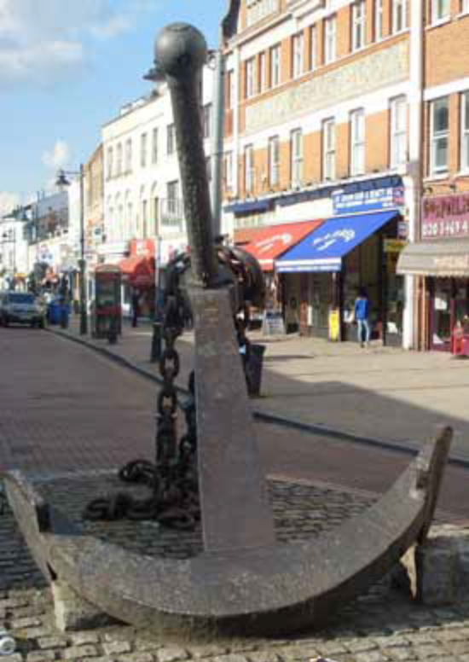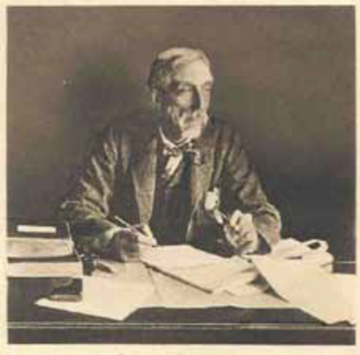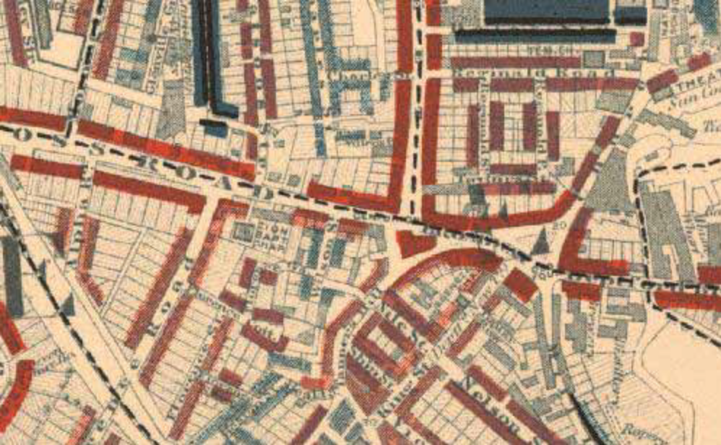
The name Deptford is derived from Deep Ford. It was here that pilgrims would ford the river on their way along the ancient Roman Road to Canterbury, what is now the A2. Four hundred years ago, Henry VIII made it the main shipbuilding and docks area for London and, as we will see, its story since then has been the story of London and the country as a whole – a story of expansion, Empire and immigration.
It is described in the "Ambulator," in 1774, as 'a large and populous town, divided into Upper and Lower Deptford, and containing two churches." The place was of old famous for its naval shipbuilding yard, a fact which is thus noticed in the work above quoted: "Deptford is most remarkable for its noble dock, where the royal navy was formerly built and repaired, till it was found more convenient to build the larger ships at Woolwich, and at other places, where there is a greater depth of water."
Stop at the Big Anchor, and hear how Charles Booth was received in Deptford in 1899.
Booth: Called upon Superintendent Wakeford at the chief office Blackheath Road. He is a man of about 50, keen and alert, a total abstainer. Received me very courteously.
After I had explained our purpose and obtained the promise of an interview at the end of the work, I was introduced to the local inspector S. Gummer.
Walk with Inspector Gummer and Sergeant Goddard over district bounded by Deptford Creek, Broadway, High Street, Creek Road and The Stowage including parts of the parish of St Paul, St Nicholas and Christchurch. Inspector Gummer is a small well-dressed portly man, jacket suit and straw hat. Has over 10 years service at Blackheath Road and knows the district well. Started at Deptford Bridge, where Deptford Creek passing under becomes the Ravensbourne. Deptford Broadway. Triangular open space paved with cobble stones. Stand for barrows and the meeting place of the neighbourhood. Political and other meetings held here. Men standing about. Good three storied shops to High Street, slightly poorer near Church Street.
Booth showed this area as red on the map, which meant “middle class” and “well-to-do”. It was the better end of town.
Corner of Hale Street and Frankham Street
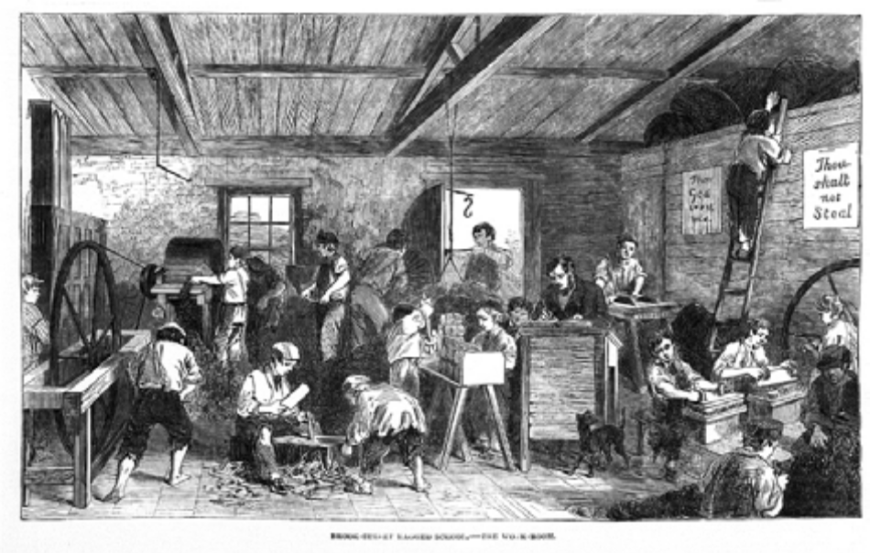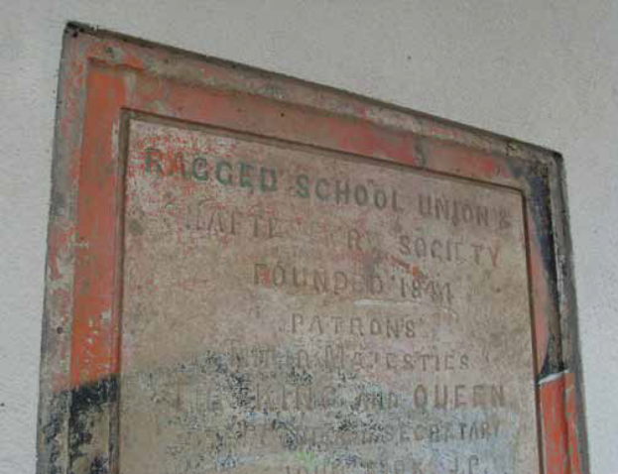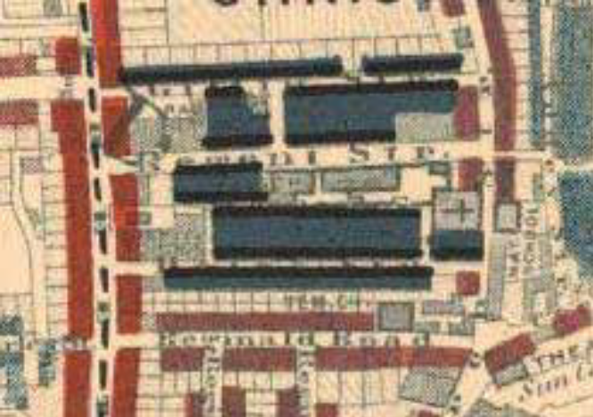
In the mid 1800s, Britain was booming – it was the world’s leading industrial power and had a vast Empire. It was also a period when the country’s population grew rapidly. But in the major cities, there was overcrowding and poor living conditions for large numbers of people. Remember, in those times there was no welfare state – the government did not provide free healthcare, education, housing and other support to poorer people.
But there were charities funded by individual philanthropists or religious organisations that cared for poorer members of society by providing free services and facilities. One such type of institution was known as ‘ragged schools’, which provided free education to poor children, and this plaque marks the site of Deptford’s Ragged School.
Charles Dickens wrote about ragged schools in The Daily News in 1852: “This attempt is being made in certain of the most obscure and squalid parts of the Metropolis, where rooms are opened, at night, for the gratuitous instruction of all comers, children or adults, under the title of RAGGED SCHOOLS. The name implies the purpose. They who are too ragged, wretched, filthy, and forlorn, to enter any other place: who could gain admission into no charity school, and who would be driven from any church door; are invited to come in here, and find some people not depraved, willing to teach them something, and show them some sympathy, and stretch a hand out, which is not the iron hand of Law, for their correction.”
Almost 50 years after Dickens wrote that, Booth was here and took note of Deptford’s Ragged School and the street that it was on:
Booth: ‘Deptford Ragged School – a large square block at W. corner of Giffen Street. Two women talking in roadway as we entered (Hale Street). Well known prostitutes said the inspector. The women moved off quickly evidently recognising him. (Some women) sitting in groups on the foot path, one on a chair, more on the edge of the curbstones which one woman completed a small circle by sitting in the road with her feet towards the curb. Candle factory at west end of street emitting very evil smells. Not much crime.’
Booth categorised this as dark blue on his map, which meant “very poor, casual, chronic want”.
Frankham Street Mural
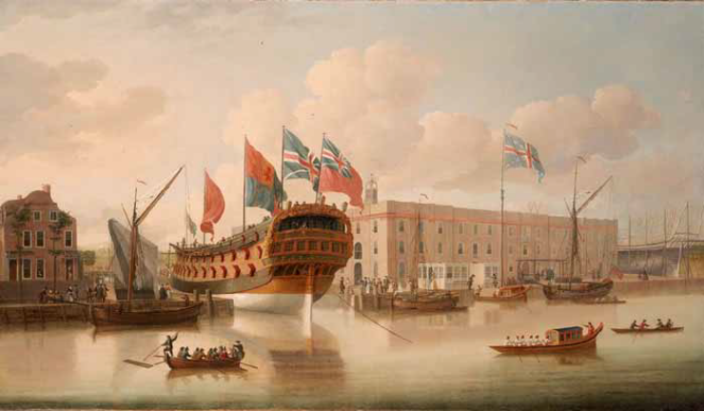
Deptford, along with a few other areas along the Thames in London, was a very important place in terms of maritime activity from the seventeenth century to the twentieth century, as we shall find out throughout this walk.
Look at the mural on the wall depicting Deptford as a hub of maritime and naval activity in the middle of the eighteenth century. The river was deep at this point and so docks could be built, and supplies of oak and other materials for shipbuilding could be brought up the Thames or along Watling Street from Kent. The road is now the busy A2.
Trade expansion and wars with other maritime nations such as Spain, France and Holland forced English shipbuilders to stay at the cutting edge of new technology. Over the centuries, famous captains such as Francis Drake, Walter Raleigh, James Cook, William Bligh and Horatio Nelson all sailed from Deptford.
Deptford High Street
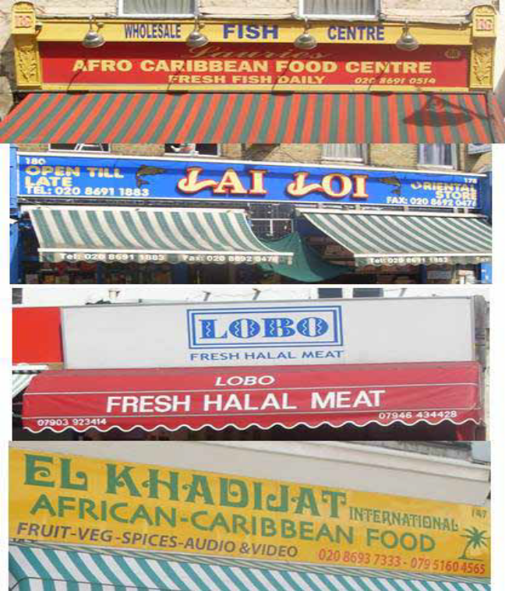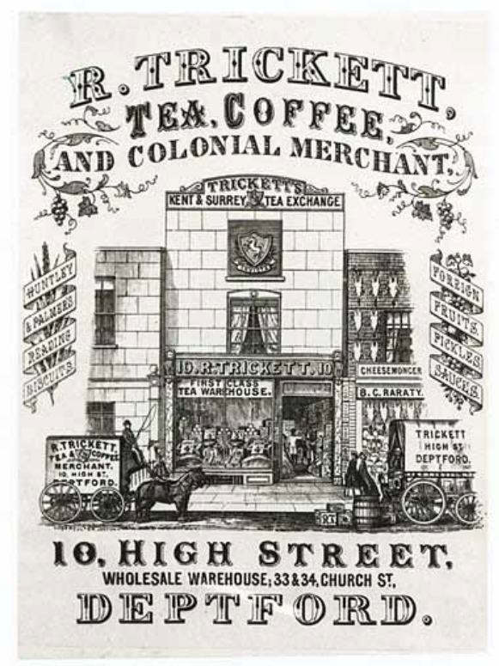
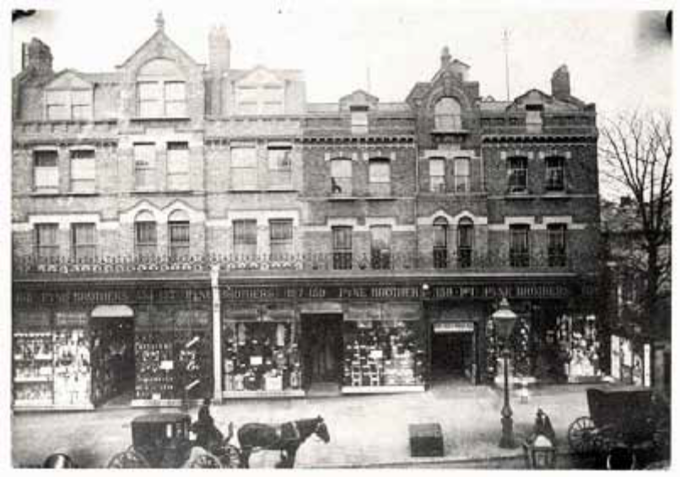
Deptford has the honour of having been the birthplace of the rag and bottle, or "marine store," trade. Its shops retain its former multiculturalism. Booth made some interesting comments about the High Street, and generally classified it was “middle class, well-to-do”.
Booth: Wide market street 2-3 storied houses, almost as many styles of buildings as houses. The only agreement being that all have shop fronts, sometimes a part of the original building but more often as an addition thereto. Most of the shopkeepers live over the shops. Best shops are nearest the Broadway, decline in character being gradual towards railway arch. An Italian colony is growing up near Knott (Creekside) Street, ice cream vendors and Asphalt workers. North of railway arch to Evelyn Street trade is less brisk and shops not as good.
Mydidee’s Grave, St Paul’s Churchyard
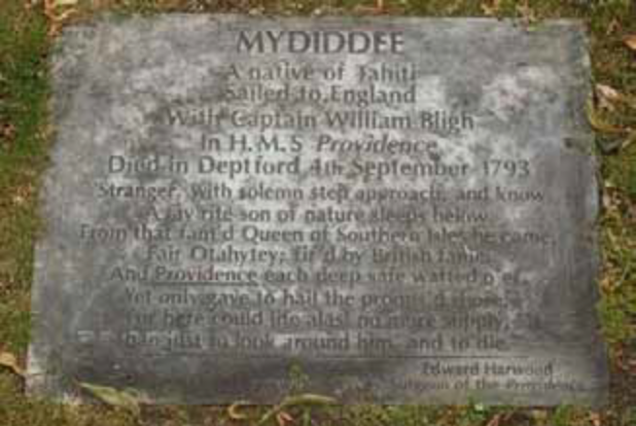 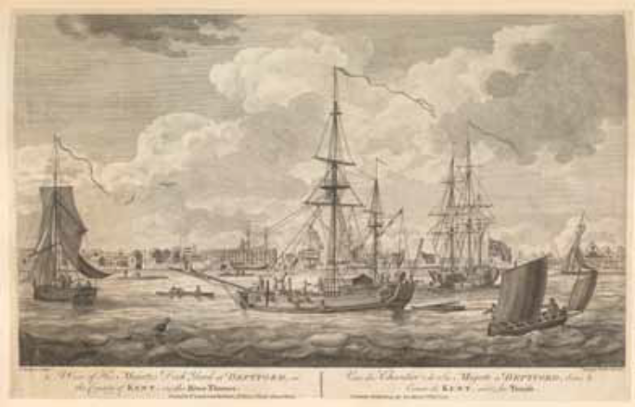
A View of His Majesty’s Dockyard at Deptford. Engraving by Carington Bowles (1772)
Over three centuries ago, Deptford was a centre for shipbuilding and people came from abroad to learn British techniques. Over two centuries ago, it was the launching point for ships that were heading out on expeditions and voyages across the world. 150 years ago it was a hive of activity as vessels docked at the wharves, bringing goods from across the empire.
Here’s something connecting Deptford with the other side of the world. Captain Bligh sailed from Deptford in 1787 on a mission to take breadfruit plants from Tahiti to the West Indies. Bligh survived the famous Mutiny in 1789 and three years later completed the mission, returning to Deptford in 1793. He brought with him a very special guest, a Tahitian prince called Mydiddee. You can read about his last months on his gravestone here at St Pauls. Mydidee’s story is a fitting end and pulls together some of the themes of seafaring, culture and class that we have explored on this walk. It is fascinating to compare Booth’s notes with the present and see just what has changed and also what has remained the same.
Crossfield Street
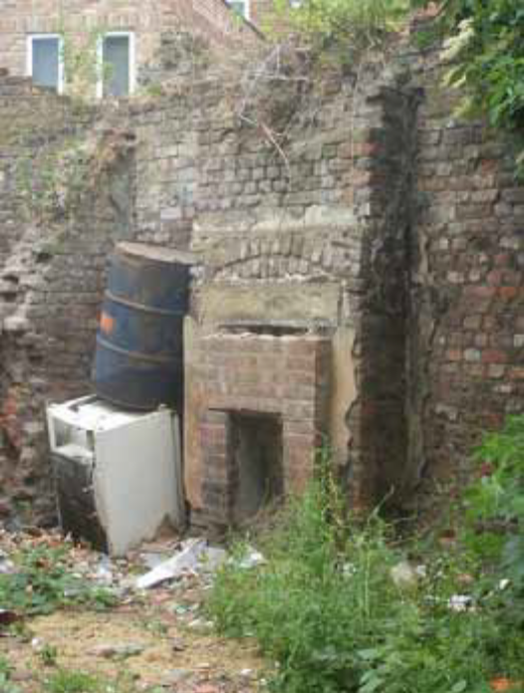 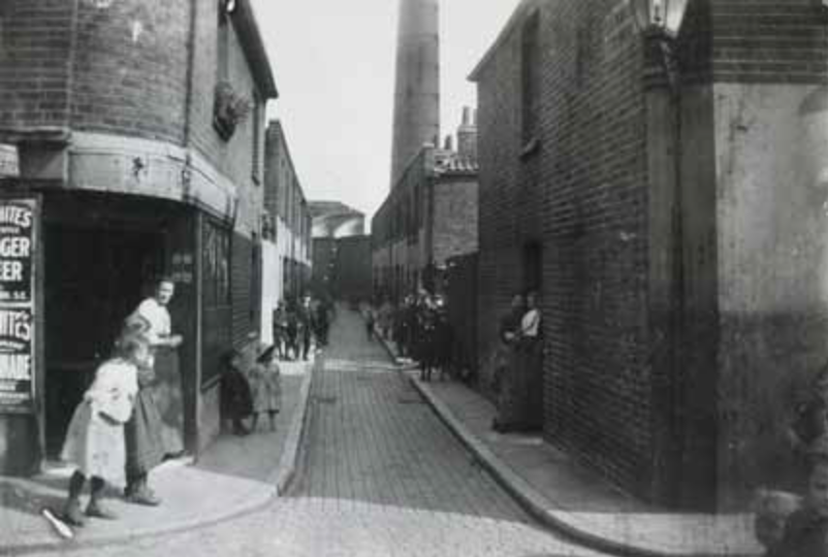
There were several types of housing typical in the Victorian era. Housing for the poor tended to be long brick terraces. In Booth’s time, there were terraces along both sides of Crossfield. One of them has now been replaced by the traffic island that you can see.
Look for the old fireplaces on the wall of the fenced-off yard next to you. This was once the kitchen parlour of a Victorian terraced house.
Here, Booth categorised the street as dark blue, meaning “very poor, casual, chronic want”.
Booth: Crossfield Lane. On south side two to three storied old houses, some used as shops. Few pairs of old boots stays and stockings strung up outside one; a very primitive second hand store. North side, very neglected, broken and dirty windows, doors open, children playing about. Costers, woodchoppers, squalid poverty.
Crossfield Estate
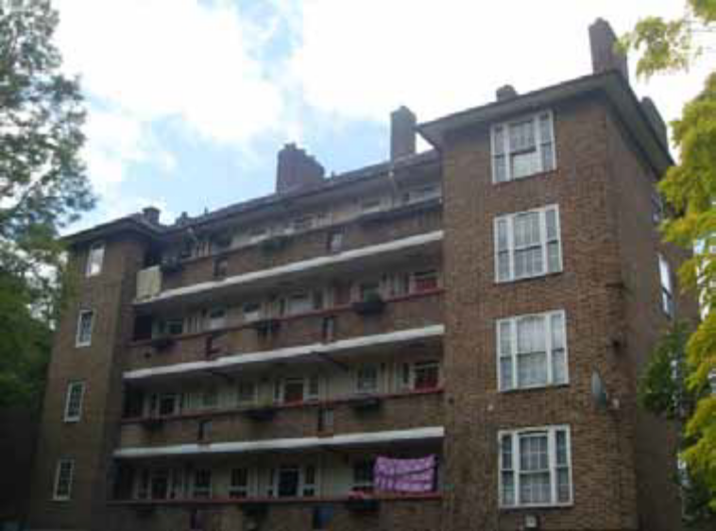
The blocks of houses you can see were built in the 1920s replacing Victorian terraces. The road itself used to be called Addey Street. In Booth’s time, the terraced houses here were overcrowded and the conditions for living were appalling, as Booth noted:
Booth: Addey Street. Small two storey houses. Four rooms and an attic in roof. Footway leading to houses is about 2 ft. below level of roadway and is protected by iron railings. Some prostitutes and criminals. Low rough class. Officer went into a house here to arrest a man at 5am. Found father, mother and 5 children in one room. All rooms are small. The inspector reckons this is worst part of Deptford.
Halfpenny Hatch Bridge
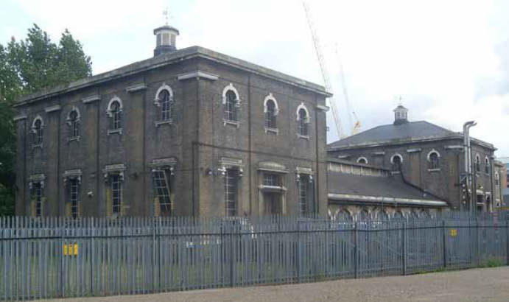 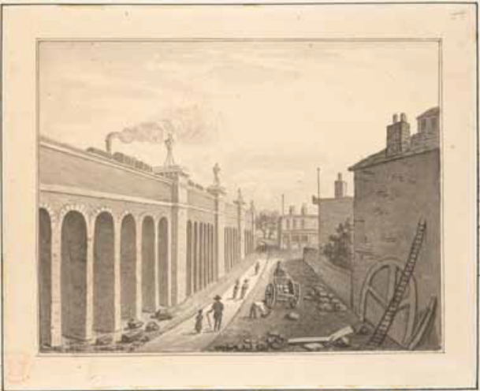
The Victorian era was also an era of technical advancement, of engineering feats and urban modernisation. And from here we can see two of the developments of the era.
Here there are two railway bridges. Just behind the concrete bridge is a Victorian brick building. This is one of Joseph Bazalgette’s great sewage pumping stations. In the middle of the nineteenth century, London was suffering from the ‘Great Stink’ as untreated sewage from an expanding population was discharged into the Thames. Bazalgette was asked by the government to find a solution and built a series of sewers and pumping stations that are still used today. The Thames is now considered the cleanest river in any capital city in Europe.
Another thing that developed on a broad scale in the Victorian era was the railways. The brick railway viaduct next to you is actually the oldest in London – it is a line going from London Bridge to Greenwich and beyond.
When the Greenwich station opened, Mr WH Smith, who had a stationery shop at London Bridge, was able to open a second shop in Greenwich and so begin his stationery empire.
Deptford station, opened in 1836, was the very first station that you could travel to from Central London. There’s more evidence of Victorian technology and ingenuity here, too. The railway line crosses the creek here, but the bridge would have prevented ships from coming up the creek, so engineers designed the tall metal structure that you can see. It took eight men to hoist this section of track up so that ships could enter. It was known as the ‘Halfpenny Hatch’ bridge, because pedestrians were charged a halfpenny for using it. When Booth came here in 1899, the price had doubled to one pence!
Deptford Creek
Beside you is the Ravensbourne River as it flows into the sea. It rises upon Keston Heath, near Hayes Common, in Kent, and runs a course of about twelve miles in all, passing Bromley and Lewisham and the southern borders of Blackheath. The ford of Deptford, however, has long since been superseded by a bridge. This bridge, according to Charles Mackay, in his "Thames and its Tributaries," is memorable in history for the total defeat of Lord Audley and his Cornish rebels in the year 1497. Headed by that nobleman and by a lawyer named Flammock, and Joseph, a blacksmith of Bodmin, they had advanced from Taunton with the design of taking possession of London. The Kentish men flocked to their standard, and on their arrival at Blackheath they amounted altogether to about 16,000 men. Lord Daubeny, who had been sent against them by King Henry VII., made a furious attack upon them at Deptford Bridge, and after great slaughter put them to flight.
Stowage
We’re closer to the river where the wharves would have been. This was a place busy with activity, as Booth described.
Booth: North into Stowage. A stinking unpaved lane with wharves on north side. On south side two storey modern homes are occupied by a low rough waterside population. This walk includes the greater part of poor Deptford. Most people living here work at one of the factories along the Creek. Besides the chemical works there are numerous business places employing a large number of ‘hands’. The Steam Navigation Company has a large yard in the Stowage. All these works are busy and work is plentiful so that no man need be unemployed. Women work in woodyard and laundry, girls in the tin factory or as ‘gut girls’ in the meat market cleaning the entrails of the slaughtered beasts. I have grave doubts as to the knowledge of the police of the social conditions of the people. They measure the streets mainly by the proportion of offences against the law and dimunation of these is an improvement which they attribute to improved social position.
What is particularly noteworthy about Booth’s comments is that there is plenty of work for the local population. The actual jobs – such as gutting animal carcasses – and working conditions were probably very unpleasant and the pay poor, but no one was idle. Places like this, with its shipyards, factories and works were the driving force behind Britain’s economic growth.
Peter the Great statue
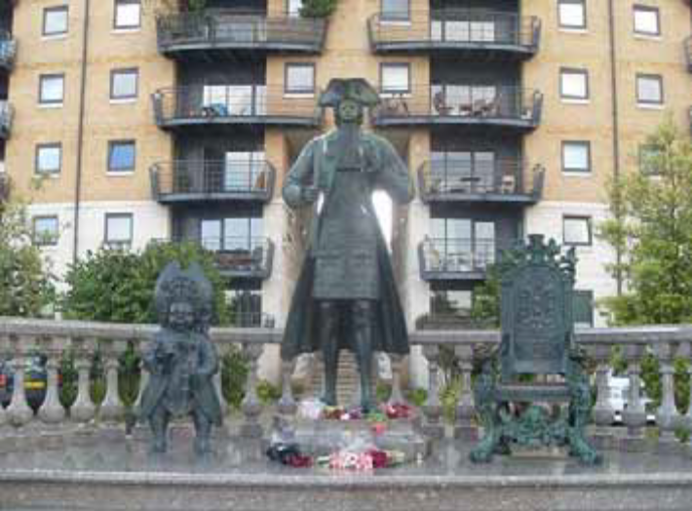
Peter the Great came to Deptford from Russia over 300 years ago – in 1698 – to learn about shipbuilding. While here, he rented the nearby manor house of Sayes Court and managed to do a great deal of damage by throwing wild drunken parties. The owner of Sayes Court – John Evelyn wrote about it in his diary:
Feb 6th 1698:
The Czar Emperor of Muscovy, having a mind to see the building of ships, hired my house at Sayes Court (Deptford), and made it his Court and Palace, lying and remaining in it, new furnished for him by the King.
June 9th 1698
I went to Deptford to view how miserably the Czar of Muscovy had left my house after three months making it his court, having got Sir Christopher Wren his Majesties surveyor and Mr. London his gardener to go down and make an estimate of the repairs, for which they allowed 150 pounds in their report to the Lord of the Treasury.

Deptford Power Station
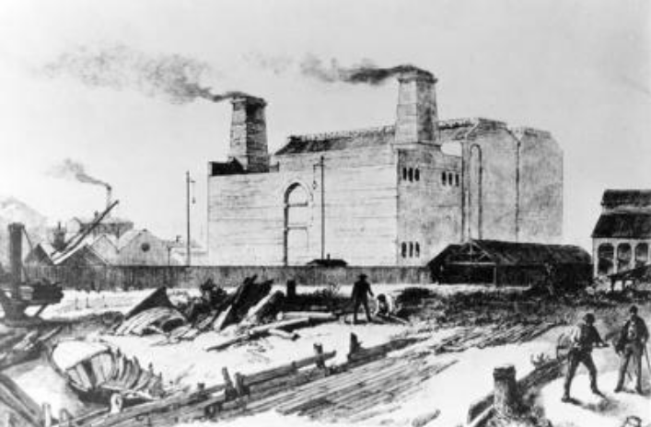 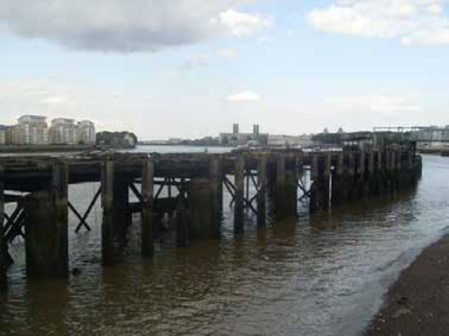
It was here that the world’s first commercial electricity plant was opened in 1889, by Sebastian Ziani de Ferranti (who was from Liverpool, despite his Italian name). Deptford was chosen because this large site had been vacated by the East India Company. It also had plenty of water and coal could be brought up the river to the landing stages you can still see, or by rail from other parts of the country. Small areas of London were already being lit by small electricity generators using direct current (dc) but Ferranti’s 400 kilowatt alternators used alternate current (ac) to send a 10,000 volt current of electricity to central London. The days of gas lighting were numbered.
Remnants of the former dockyard
‘The Royal Dock, or "King's Yard," as it was locally called in former times, was esteemed one of the most complete repositories for naval stores in Europe. It covered not less than thirty acres of ground, and contained every convenience for building, repairing, and fitting out ships-of-the-line—those veritable "wooden walls of Old England" with which we were familiar before the introduction of armour-plated vessels. Artificers in wood and in iron had here large ranges of workshops and storehouses; and here the hammer and the axe were scarcely ever idle, even in times of peace; but where, during the prevalence of war, they were plied incessantly "in the construction of those floating bulwarks for which England is, or rather was, renowned, and which carry a hundred and twenty guns and a thousand men to guard her shores from the invader, or to bear her fame with her victories to the remotest seas of the ocean."
The yard was occupied by various buildings, such as two wet docks (one double and the other single), three "slips" for men-of-war, a basin, two mast ponds, a model loft, mast houses, a large smith's shop, together with numerous forges for anchors, sheds for timber, &c., besides houses for the officers who superintended the works. The finest machinery in the world is said to have been employed in Deptford Dockyard for spinning hemp and manufacturing ropes and cables for the service of the navy. The large storehouse on the north side of the quadrangle was erected in the year 1513. This may be said to have been the commencement of the works at Deptford, which under successive sovereigns gradually grew up and extended.’
Pepys writes under date April 28th, 1667:—"To Deptford, and there I walked down the yard, … and discovered about clearing of the wet docke, and heard (which I had before) how, when the docke was made, a ship of nearly 500 tons was there found; a ship supposed of Queen Elizabeth's time, and well wrought, with a great deal of stoneshot in her, of eighteen inches diameter, which was shot then in use; and afterwards meeting with Captain Perryman and Mr. Castle at Half-way Tree, they tell me of stone-shot of thirty-six inches in diameter, which they shot out of mortar pieces."
Again, in the following May:—"By water to Deptford, it being Trinity Monday, when the Master is chosen. And so I down with them; and we had a good dinner of plain meat, and good company at our table; among others my good Mr. Evelyn, with whom, after dinner, I stepped aside and talked upon the present posture of our affairs." Again, when in June, 1667, the alarm was raised that the Dutch fleet was already off the Nore and in the Medway, Samuel Pepys relates another official visit: "So we all down to Deptford, and pitched upon ships, and set men at work; but Lord! to see how backwardly things move at this pinch."
Riverside
To get a picture of what it was like a hundred years ago, let’s hear a description of the Thames at this point in 1902 from Joseph Conrad’s novel Heart of Darkness.
‘The sea-reach of the Thames stretched before us like the beginning of an interminable waterway. In the offing the sea and the sky were welded together without a joint, and in the luminous space the tanned sails of the barges drifting up with the tide seemed to stand still in red clusters of canvas sharply peaked, with gleams of varnished spirits. A haze rested on the low shores that ran out to sea in vanishing flatness. The air was dark above Gravesend, and farther back still seemed condensed into a mournful gloom, brooding motionless over the biggest, and the greatest, town on earth.
The tidal current runs to and fro in its unceasing service, crowded with memories of men and ships it had borne to the rest of home or to the battles of the sea....It had known the ships and the men. They had sailed from Deptford, from Greenwich and from Erith - the adventurers and the settlers; kings’ ships and the ships of men...hunters for gold or pursuers of fame, they all had gone out on that stream, bearing the sword and often the torch...What greatness had not floated on the ebb of that river into the mystery of an unknown earth!...The dreams of men, the seed of commonwealths, the germ of empires.’
And Dickens, from the Uncommercial Traveller:
‘Down by the Docks, they eat the largest oysters and scatter the roughest oyster-shells, known to the descendants of Saint George and the Dragon. Down by the Docks, they consume the slimiest of shell-fish, which seem to have been scraped off the copper bottoms of ships. Down by the Docks, the vegetables at green-grocers' doors acquire a saline and a scaly look, as if they had been crossed with fish and seaweed. Down by the Docks, they 'board seamen' at the eating-houses, the public-houses, the slop-shops, the coffee-shops, the tally-shops, all kinds of shops mentionable and unmentionable--board them, as it were, in the piratical sense, making them bleed terribly, and giving no quarter. Down by the Docks, the seamen roam in mid-street and mid-day, their pockets inside out, and their heads no better. Down by the Docks, the daughters of wave-ruling Britannia also rove, clad in silken attire, with uncovered tresses streaming in the breeze, bandanna kerchiefs floating from their shoulders, and crinoline not wanting. Down by the Docks, you may hear the Incomparable Joe Jackson sing the Standard of England, with a hornpipe, any night; or any day may see at the waxwork, for a penny and no waiting, him as killed the policeman at Acton and suffered for it. Down by the Docks, you may buy polonies, saveloys, and sausage preparations various, if you are not particular what they are made of besides seasoning. Down by the Docks, the children of Israel creep into any gloomy cribs and entries they can hire, and hang slops there--pewter watches, sou'-wester hats, waterproof overalls--'firtht rate articleth, Thjack.' Down by the Docks, such dealers exhibiting on a frame a complete nautical suit without the refinement of a waxen visage in the hat, present the imaginary wearer as drooping at the yard-arm, with his seafaring and earthfaring troubles over. Down by the Docks, the placards in the shops apostrophise the customer, knowing him familiarly beforehand, as, 'Look here, Jack!' 'Here's your sort, my lad!' 'Try our sea-going mixed, at two and nine!' 'The right kit for the British tar!' 'Ship ahoy!' 'Splice the main-brace, brother!' 'Come, cheer up, my lads. We've the best liquors here, And you'll find something new In our wonderful Beer!' Down by the Docks, the pawnbroker lends money on Union-Jack pocket-handkerchiefs, on watches with little ships pitching fore and aft on the dial, on telescopes, nautical instruments in cases, and such-like. Down by the Docks, the apothecary sets up in business on the wretchedest scale--chiefly on lint and plaster for the strapping of wounds--and with no bright bottles, and with no little drawers. Down by the Docks, the shabby undertaker's shop will bury you for next to nothing, after the Malay or Chinaman has stabbed you for nothing at all: so you can hardly hope to make a cheaper end. Down by the Docks, anybody drunk will quarrel with anybody drunk or sober, and everybody else will have a hand in it, and on the shortest notice you may revolve in a whirlpool of red shirts, shaggy beards, wild heads of hair, bare tattooed arms, Britannia's daughters, malice, mud, maundering, and madness. Down by the Docks, scraping fiddles go in the public-houses all day long, and, shrill above their din and all the din, rises the screeching of innumerable parrots brought from foreign parts, who appear to be very much astonished by what they find on these native shores of ours. Possibly the parrots don't know, possibly they do, that Down by the Docks is the road to the Pacific Ocean, with its lovely islands, where the savage girls plait flowers, and the savage boys carve cocoa-nut shells, and the grim blind idols muse in their shady groves to exactly the same purpose as the priests and chiefs. And possibly the parrots don't know, possibly they do, that the noble savage is a wearisome impostor wherever he is, and has five hundred thousand volumes of indifferent rhyme, and no reason, to answer for.’
If you want to continue further, head to Greenwich…
The Cutty Sark was built in 1869 at a cost of £16,500. She was one of the last tea clippers to be built, and is also one of the fastest. In fact, at one stage in her career she was thought to be the fastest freight ship in the world. It was retired in 1954 and has been in a ‘dry dock’ ever since. Badly damaged by fire in May 2007, the Cutty Sark has undergone a £35million restoration project and is now open again to the public.
The Greenwich Foot Tunnel, designed by Sir Alexander Binnie for the dock-men who worked and lived on different sides of the Thames, was opened on 4th August 1902, replacing an earlier (more expensive) ferry service. The entrance shafts at both ends are housed underneath giant domes and access is granted via stairs or lift. The tunnel itself has an internal diameter of 9 ft (2.74m), is 50ft (15.2m) deep and is 1,215ft (370m) long. The entire tunnel is coated in 200,000 white glazed titles and is open to the public 24 hours a day.
Greenwich Market. There has been a market in Greenwich for centuries owing to a permission granted in 1700 to the
Commissioners of Greenwich Hospital giving the right to hold a market here for the next 1,000 years!
Greenwich Park was the first Royal Park of London to be enclosed (in 1433) and stretches over 74 hectares (180 acres). The land here was given to King Henry IV by his uncle, the Duke of Gloucester in 1427. Henry VIII used the park for hunting and it was opened to the public during the 18th century.
The National Maritime Museum, located at the bottom of the park, is the largest maritime museum in the entire world. Established in 1937, it houses a collection of over 2 million objects including over 2,000 model ships!
The Queen’s House is a formal royal residence and dates from around 1619. It was designed by Inigo Jones for Anne of Denmark, the queen of King James I and was later altered for queen Henrietta Maria, wife of King Charles I, hence the ngreenwich-queens-house-3ame of the house. The view of the river from The Queen’s House is actually a protected view and explains why Christopher Wren’s Naval College (which stands between you and the Thames) is made up of two identical buildings that are not connected to each other. Wren was given specific instructions not to impede the view of the Thames from the Queen’s House, which meant he couldn’t connect the two wings of the College!
And through the tunnel to the Isle of Dogs…
Island Gardens was originally a dump and became known as ‘Scrap Iron Park’ in the early 19th century. The pollution and growth of industrial developments on the Island caused concern at Greenwich hospital across the river and the area was cleared and laid out as a much-needed riverside park space in 1895.
Walk to Millwall Dock, built between 1865 – 1867, this was at the time the largest lock in London. It was 80 ft wide, and had two chambers of 247 and 198 ft. Badly damaged in the War, it was dammed up in 1956, but has recently undergone major refurbishment. Head along Millwall Dock into West India Dock, and through to Canary Wharf, and take a visit to the brilliant Museum of the London Docklands.
Further information
Charles Booth Online Archive. Major archive featuring searchable copies of Booth’s maps http://booth.lse.ac.uk/
Edward Walford, 'Deptford', in Old and New London: Volume 6 (London, 1878), pp. 143-164. British History Online http://www.british-history.ac.uk/old-new-london/vol6/pp143-164.
Old Deptford History. http://www.olddeptfordhistory.com
Sean Patterson, District 45: A Self-guided walk through London’s Deptford. Discovering Britain https://www.discoveringbritain.org/london-deptford.html
South London Guide: Deptford. History of the area plus a large collection of period images and maps http://www.southlondonguide.co.uk/deptford/index.htm
Tower Hamlets, ‘Isle of Dogs Walks’, https://www.towerhamlets.gov.uk/lgnl/leisure_and_culture/walking/walks/isle_of_dogs.aspx

