1. John Betjeman, Metro-Land (1973)
‘Voysey’s House’, Chorleywood.
What features of suburbia are reflected in Betjeman’s film?
What characterises Betjeman’s attitude to suburbia?

2. Primary Source Questions
What are the causes for London's suburban expansion over the early 20th century?
What significant features define the new suburbia, and what did it become associated with?

1. Masterman and Building News

a) C.F.G. Masterman, The Condition of England (1909)
1. a) ‘They form a homogenous civilization – detached, self-centred, unostentatious – covering the hills along the northern and southern boundaries of the city, and spreading their conquests over the quiet fields beyond. It is a life of Security; a life of Sedentary occupation; a life of Respectability … Its male population is engaged in all its working hours in small, crowded offices, under artificial light, doing immense sums, adding up other men’s accounts, writing other men’s letters. It is sucked into the City at daybreak and scattered again as darkness falls. It finds itself towards evening in its own territory in the miles and miles of little red houses in little, silent streets, in numbers defying imagination. Each boasts its pleasant drawing-room, its bow-window, its little front garden, its high-sounding title – ‘Acacia Villa’ or ‘Camperdown Lodge’ – attesting unconquered human aspiration … The women, with their single domestic servants … find time rather heavy on their hands. But there are excursions to shopping centres in the West End, and pious sociabilities, and occasional theatre visits, and the interests of home.’

b) The Building News and Engineering Journal (1900)
b) ‘Go where we will – north, south, east or west of this huge over-grown Metropolis, the fungus like growth of houses manifests itself stretching from town to suburb and village – as from the southern suburbs to Herne Hill and Dulwich, and from Streatham to Croydon. In every direction we see the same outward growth of dwelling houses of a small and unpretending class – generally a repetition of a type of house that has been found to meet the requirements of the middle class and artisan. The larger and more commodious residence of fifty years ago is being pulled down, or swamped by this tide of small houses: where a large house existed ten, or a hundred or more have been built, absorbing the acres of gardens and private park lands. This is one of the social revolutions of the age.’

2. H.G. Wells, Anticipations (1902)
‘We are … in the early phase of a great development of centrifugal possibilities. … The available area of a city which can offer a cheap suburban journey of thirty miles an hour is a circle with a radius of thirty miles. And is it too much … to expect that the available area for even the common daily toilers of the great city of the year 2000, or earlier, will have a radius very much larger even than that? … Indeed, it is not too much to say that the London citizen of the year 2000 AD may hae a choice of nearly all England and Wales south of Nottingham and east of Exeter as his suburb … And so, though the centre will probably still remain the centre and ‘Town’, it will be essentially a bazaar, a great gallery of shops and places of concourse and rendezvous, a pedestrian place … and altogether a very spacious, brilliant, and entertaining agglomeration.
Enough now has been said to determine the general nature of the expansion of the great cities in the future, so far as the more prosperous classes are concerned. It will not be a regular diffusion … but a process of throwing out the ‘homes’ and of segregating various types of people. The omens seem to point … to a wide and quite unprecedented diversity in the various suburban townships and suburban districts … But the diffusion of the prosperous, independent, and managing classes involves in itself a very considerable diffusion of the purely ‘working’ classes also. Their centres of occupation will be distributed, and their freedom to live at some little distance from their work will be increased.’

3. George Orwell, Coming Up For Air (1939)
‘You know how these streets fester all over the inner-outer suburbs. Always the same. Long, long rows of little semi-detached houses-- the numbers in Ellesmere Road run to 212 and ours is 191--as much alike as council houses and generally uglier. The stucco front, the creosoted gate, the privet hedge, the green front door. The Laurels, the Myrtles, the Hawthorns, Mon Abri, Mon Repos, Belle Vue. At perhaps one house in fifty some anti-social type who'll probably end in the workhouse has painted his front door blue instead of green.
… It was almost as if I could stand at a distance and watch myself coming down the road, with my fat, red face and my false teeth and my vulgar clothes. A chap like me is incapable of looking like a gentleman. Even if you saw me at two hundred yards' distance you'd know immediately--not, perhaps, that I was in the insurance business, but that I was some kind of tout or salesman. The clothes I was wearing were practically the uniform of the tribe. Grey herring-bone suit, a bit the worse for wear, blue overcoat costing fifty shillings, bowler hat, and no gloves. And I've got the look that's peculiar to people who sell things on commission, a kind of coarse, brazen look. At my best moments, when I've got a new suit or when I'm smoking a cigar, I might pass for a bookie or a publican, and when things are very bad I might be touting vacuum cleaners, but at ordinary times you'd place me correctly. 'Five to ten quid a week', you'd say as soon as you saw me. Economically and socially I'm about at the average level of Ellesmere Road.
I had the street pretty much to myself. The men had bunked to catch the 8.21 and the women were fiddling with the gas-stoves. When you've time to look about you, and when you happen to be in the right mood, it's a thing that makes you laugh inside to walk down these streets in the inner-outer suburbs and to think of the lives that go on there. Because, after all, what IS a road like Ellesmere Road? Just a prison with the cells all in a row. A line of semidetached torture-chambers where the poor little five-to-ten- pound-a-weekers quake and shiver, every one of them with the boss twisting his tail and his wife riding him like the nightmare and the kids sucking his blood like leeches. There's a lot of rot talked about the sufferings of the working class. I'm not so sorry for the proles myself. Did you ever know a navvy who lay awake thinking about the sack? The prole suffers physically, but he's a free man when he isn't working. But in every one of those little stucco boxes there's some poor bastard who's NEVER free except when he's fast asleep and dreaming that he's got the boss down the bottom of a well and is bunging lumps of coal at him.
Next page: 4), 5) and 6) – choose one pairs of images.

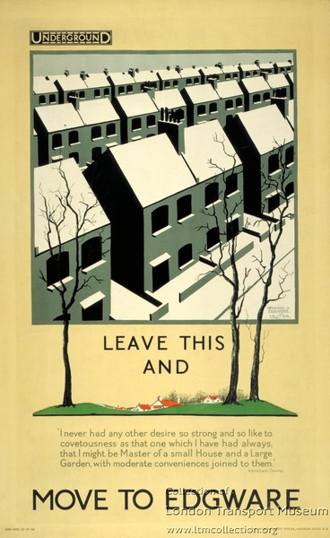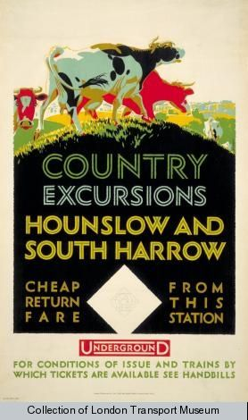
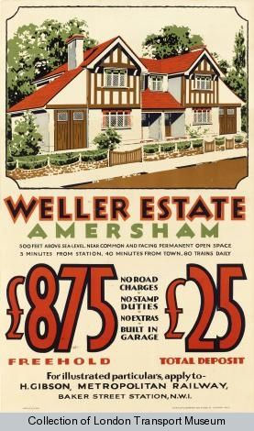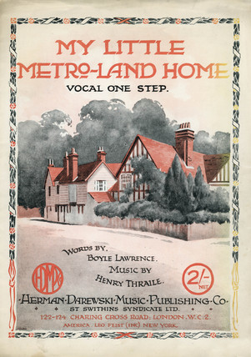
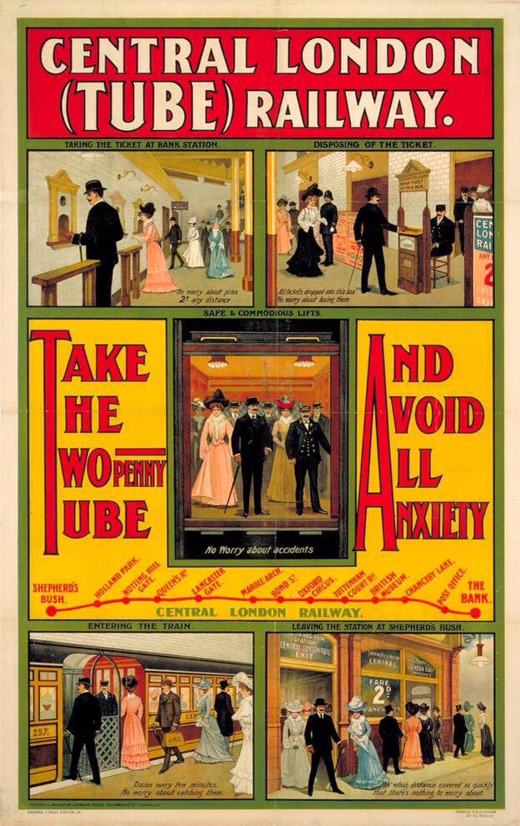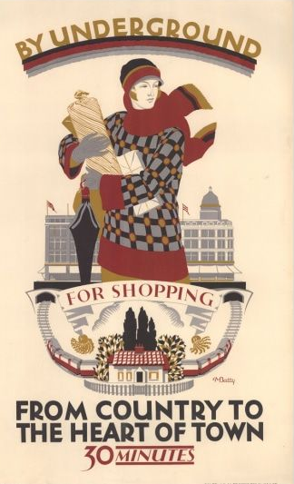

3. Blog activity
Focus on one blog entry, either Becontree, Downham or East Sheen
- What was the significance of new council estates like Becontree and Downham? What ideas were behind them, and how successful were they in realising their aims?
- If East Sheen, how did suburban building reflect contemporary social concerns?
- Focusing on its writing, presentation and structure, how does the blog-post effectively describe and historicise one particular London landmark?

https://municipaldreams.wordpress.com/2013/01/08/the-becontree-estate-built-in-england-where-the-most-revolutionary-social-changes-can-take-place-and-people-in-general-do-not-realise-that-they-have-occurred
https://municipaldreams.wordpress.com/2013/05/21/the-downham-estate-the-joy-of-having-your-own-patch
https://flickeringlamps.com/2015/10/10/a-block-of-flats-in-south-west-london-with-its-own-second-world-war-air-raid-shelter

