

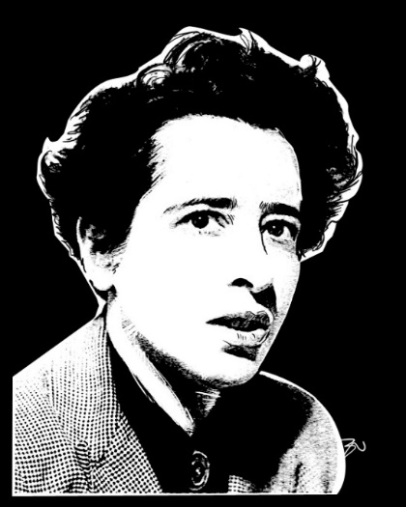
Hannah Arendt:
Thinking in Difficult Times
Tutor: Dan Taylor (Dan.Taylor@marywardcentre.ac.uk)
17 September – 3 December 2018
Monday 15.30-17.30, Room 14, 42 Queen Square, WC1N 3AQ

Week 1. 17th Sept Introducing Hannah Arendt “What Remains?”; Eichmann
Week 2. 24th Sept The Banality of Evil Eichmann in Jerusalem
Week 3. 1st Oct Refugees and to live without rights Origins of Totalitarianism 1
Week 4. 8th Oct Racism and Imperialism Origins of Totalitarianism 2
Week 5. 15th Oct Totalitarianism (‘Truth isn’t truth’) Origins of Totalitarianism 3
Week 6. 22nd Oct Politics and Lying “Truth and Politics”;
“Lying and Politics”
Week 7. 29th Oct Arendt and the Civil Rights movement “Little Rock”, Jewish Writings
Week 8. 5th Nov Violence, Power and Revolution On Revolution
Week 9. 12th Nov Jefferson and the Revolutionary Spirit On Revolution
Week 10. 19th Nov The Vita Activa The Human Condition
Week 11. 26th Nov Equality, Plurality, Freedom The Human Condition
Week 12. 3rd Dec Thinking without a Banister Life of the Mind

