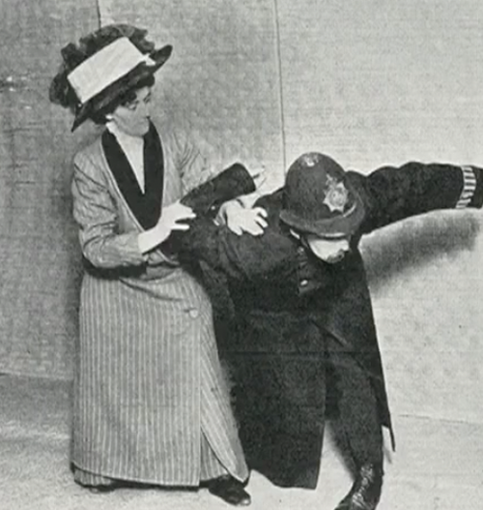



Political Philosophy
Tutor: Dan Taylor (Dan.Taylor@marywardcentre.ac.uk)
14 January – 1 April 2019
Monday 15.30-17.30, Room 14, 42 Queen Square, WC1N 3AQ

If much of modern political discourse is dispiriting, this is perhaps because it engages less and less with the ideas that make political life meaningful. Instead of assuming the entrenched positions of the left, the right or the centre, we will investigate the different ideas and competing intuitions that make sense of these positions. We will see that such apparently basic terms such as ‘justice’, ‘fairness’, ‘equality’ ‘rights’ and so on can be given different and competing interpretations, but that learning to analyse these can help make sense of the world around us and how we think about that world. The course will range from the agora of ancient Greece, through the tumult of the Enlightenment, the struggles of the 19th and the 20th Century and the howling denizens of today’s internet-driven political culture. We will look to contextualise debates through the analysis of real world problems and also examine the question of whether the political philosophies of the past and even the present can be adequate to the looming political issues of the near future.

1.Who is this course for?
This course is at an Upper Intermediate level and so would not be suitable for people who are new to studying philosophy. It would be an ideal continuation course for students who have previously studied on our Intermediate level courses and who now want a course that looks at one field of philosophy in depth. It may also be suitable for people who have had some previous grounding in politics or philosophy and who now want to study both in more depth.

Although you should have some previous experience of studying philosophy or politics it is not expected that you need to have a great deal of familiarity with the history of political philosophy, as this is what the course will aim to provide.

2. What this course could lead to.
Other Advanced level Philosophy courses at the Mary Ward Centre or other similar establishments. Or, other courses in the Humanities and Social Sciences with a strong emphasis on theory and the study of the mind and human behaviour (e.g., Psychology, Economics, Sociology, Anthropology, History). The course might correspond well with another Mary Ward course on Hannah Arendt, a 20th century German-born political thinker, which takes place at the same day and time the previous term, and at the same level.

3. What does this course cover
What makes a society just? Why do some rule over others? Is democracy best? What causes inequality and what should be done about it? Where do we draw the line between individual freedom and the security of the state? What might an ideal society look like? How have peaceful societies drifted into war or totalitarianism?

Working at the intersections of politics and philosophy, this course sets out to investigate and discuss key questions about how society should be organised. Drawing on philosophical concepts past and present, the course will thematically investigate some of the major issues facing societies, from justice to democracy, freedom, equality, protest, revolution and human rights. As well as covering the key figures in the western tradition of political philosophy like Plato, Aristotle, Machiavelli, Hobbes, Spinoza, Locke, Rousseau, Kant, Mill and Marx, we’ll also explore women political philosophers like Mary Wollstonecraft, Sarah Grimké and Jane Addams, and revolutionaries and rebels like Toussaint Louverture, Rosa Luxemburg, Gandhi, and Malcolm X. The course will then turn to modern political thought, exploring how thinkers as diverse as Hannah Arendt, John Rawls, Ayn Rand, Martha Nussbaum, and Peter Singer have questioned the nature of politics in relation to postcolonialism, individual freedom and collective responsibility, the rise and fall of totalitarianism, globalised capitalism, animal rights, and ever-widening inequalities.

By the end of this course you will be able to:
- explain the meanings of key terms in political philosophy like justice, democracy, rights, citizenship, equality, and freedom.
- relate the key ideas of classic political thinkers to contemporary political issues
- read with greater confidence and autonomy some of the key texts in political philosophy
- discuss and evidence your understanding of politics in relation to a wider set of thinkers and contexts.

4. What will it be like?
The course will be an interactive mixture of tutor exposition, class discussion and group/pair work. Videos and clips will be used to supplement some of these class-based activities. There are opportunities for further discussion and reading outside of the class via the course’s Moodle website.

We will assess your expectations of the course in the first sessions. Thereafter, you will be able to monitor your progress on the course through participation in class discussion, questions and answers and in-class exercises. At the end of the course, you will be able to measure your progress against the stated outcomes for the course, and through your enhanced ability to think about and discuss key concepts in political philosophy like citizenship, justice, equality and revolution.

5. What else do you need to buy or do
Please bring a notebook, pen, and an open mind. Reading materials for the course will be provided online via the Mary Ward Centre’s Moodle website and as photocopies. As we will be covering a wide swathe of thinkers, recommending a single universal text is difficult, but for introductions to the subject, Jonathan Wolff’s Introduction to Political Philosophy or David Miller’s Political Philosophy: A Very Short Introduction are recommended. There are also a couple of good anthologies which contain most of our key texts, e.g. Cahn’s Political Philosophy: The Essential Texts, or Schumaker’s Political Theory Reader. Each class will have a small amount of set reading expected outside class, no more than 30 mins per week.

